    Joint Collaborative Team on Video Coding (JCT-VC)  of ITU-T SG16 WP3 and ISO/IEC JTC1/SC29/WG11  21st Meeting: Warsaw, PL, 19–26 Jun. 2015 | Document: JCTVC-U1002

Title: | High Efficiency Video Coding (HEVC) Test Model 16 (HM 16) Improved Encoder Description Update 3
Status: | Output Document of JCT-VC
Purpose: | Report
Author(s) or  Contact(s): | C. Rosewarne  B. Bross  M. Naccari  K. Sharman  G. Sullivan | Email: | chris.rosewarne@cisra.canon.com.au  benjamin.bross@hhi.fraunhofer.de  matteo.naccari@bbc.co.uk  karl.sharman@eu.sony.com  garysull@microsoft.com
Source: | Editors
_____________________________

Abstract
The JCT-VC established the HEVC Test Model 16.7 at its 21st meeting in Warsaw from 19 June to 26 June 2015. This document serves as an overview of HEVC Version 1 and the Range Extensions of HEVC Version 2 and also provides an encoder-side description of the HM-16.7 software.
CONTENTS
Page
Abstract 1
List of figures 5
List of tables 7
1 Introduction 8
1.1 Overview of coding structures 8
1.2 Obtaining the HEVC test model 9
1.3 Obtaining the HEVC Standard 9
2 Scope 9
3 Encoder control of the HEVC test model 16 9
3.1 Encoder configuration options 9
3.1.1 File, format and profile/level/tier configuration options 9
3.1.2 Coding tool configuration options 9
3.1.3 Slice coding parameters 11
3.1.4 SEI message configuration options 11
4 Overview of tools in HEVC Version 1 and HEVC Version 2 RExt 11
4.1 High level syntax 11
4.2 Picture partitioning 11
4.2.1 Coding tree unit (CTU) partitioning 11
4.2.2 Slice and tile structures 12
4.2.3 Coding unit (CU) and coding tree structure 13
4.2.4 Prediction unit (PU) structure 13
4.2.5 Transform unit (TU) and transform tree structure 14
4.3 Intra prediction 15
4.3.1 Prediction modes 15
4.3.2 Filtering of neighbouring samples 16
4.3.3 Intra boundary filter 17
4.3.4 4:2:2 chroma format mode adjustment 18
4.4 Inter prediction 19
4.4.1 Prediction modes 19
4.4.1.1 Derivation of candidates for merge mode 20
4.4.1.2 Spatial candidates derivation 20
4.4.1.3 Temporal candidates derivation 21
4.4.1.4 Additional candidates insertion 22
4.4.1.5 Motion estimation regions for parallel processing 23
4.4.2 Motion vector prediction 23
4.4.2.1 Derivation of motion vector prediction candidates 23
4.4.2.2 Spatial motion vector candidates 23
4.4.2.3 Temporal motion vector candidates 24
4.4.3 Interpolation filter 24
4.4.4 Weighted Prediction 25
4.4.4.1 High precision offsets 25
4.5 Transform and quantization (scaling) 26
4.5.1 Inverse transforms 26
4.5.2 1D inverse transform matrices 26
4.5.3 Scaling and quantization 26
4.5.4 Scaling lists 27
4.5.5 Scaling lists for transform skipped TUs 27
4.5.6 Transform selection for the 4:2:2 chroma format 27
4.5.7 Chroma QP initialization offset table 28
4.5.8 Extended precision processing 28
4.5.9 CU-adaptive chroma QP offset 29
4.6 Slice QP offset 29
4.7 Residual prediction in case of transquant bypass and transform skip 29
4.8 Entropy coding 29
4.8.1 CABAC alignment 30
4.9 Coefficient Coding 30
4.9.1 Transform skip residual rotation 30
4.9.2 Significance map context modelling 30
4.9.3 Rice parameter adaptation 30
4.9.4 Maximum coeff_abs_level_remaining codeword length restriction 30
4.10 Cross-component prediction 31
4.11 Loop Filtering 31
4.11.1 Overview of Loop filtering 31
4.11.2 Deblocking filter 32
4.11.2.1 Boundary decision 32
4.11.2.2 Boundary strength calculation 32
4.11.2.3 Threshold variables 33
4.11.2.4 Filter on/off decision for 4 lines 34
4.11.2.5 Strong/weak filter selection for 4 lines 34
4.11.2.6 Strong filtering 34
4.11.2.7 Weak filtering 35
4.11.2.8 Chroma filtering 35
4.11.3 Sample adaptive offset filter 36
4.11.3.1 Operation of each SAO type 36
4.12 Wavefront parallel processing 37
5 Profiles, Levels and Tiers 37
6 Description of HM Encoder and encoding methods 39
6.1 Cost Functions 39
6.1.1 Sum of Square Error (SSE) 39
6.1.2 Sum of Absolute Difference (SAD) 39
6.1.3 Hadamard transformed SAD (SATD) 40
6.1.4 RD cost functions 40
6.1.4.1 Lagrangian constant values 40
6.1.4.2 Weighting factor for chroma component 40
6.1.4.3 SAD based cost function for prediction parameter decision 41
6.1.4.4 SATD based cost function for prediction parameter decision 41
6.1.4.5 Cost function for mode decision 41
6.2 Encoder configurations 41
6.2.1 Overview of encoder configurations 41
6.2.2 Intra-only configuration 41
6.2.3 Low-delay configurations 41
6.2.4 Random-access configuration 42
6.3 Slice and tile partitioning operation 42
6.4 Derivation process for slice-level coding parameters 43
6.4.1 Sample Adaptive Offset (SAO) parameters 43
6.4.1.1 Search the SAO type with minimum rate-distortion cost 43
6.4.1.2 Slice level on/off Control 43
6.4.2 Adaptive QP selection 43
6.4.3 Adaptive search range for motion estimation 43
6.5 Derivation process for CU-level and PU-level coding parameters 44
6.5.1 Intra prediction mode and parameters 44
6.5.1.1 Rate-distortion penalty for intra coding 44
6.5.2 Inter prediction mode and parameters 44
6.5.2.1 Derivation of motion parameters 44
6.5.2.2 Motion estimation 45
6.5.2.3 Decision process on AMP mode evaluation procedure 47
6.5.3 Intra/Inter/PCM mode decision 48
6.5.4 Adaptive QP 50
6.6 Derivation process for TU-level coding parameters 50
6.6.1 Residual Quad-tree partitioning 50
6.6.2 Rate-distortion optimized quantization 51
6.6.3 Quantization rounding for residual DPCM 51
6.7 Cross-component prediction 51
6.8 Transform skip selection 51
6.9 Cost mode 52
6.10 Inter-prediction search 52
6.11 Rate control 52
7 References 54

List of figures
Figure 1-1 – Simplified block diagram of HM encoder 8
Figure 4-1 – Example of a picture divided into CTUs. 12
Figure 4-2 – Example of slices and slice segments 12
Figure 4-3 – Examples of tiles and slices 13
Figure 4-4 – Example of coding tree structure 14
Figure 4-5 – 8 partition modes for inter PU 14
Figure 4-6 – Example of transform tree structure within CU 15
Figure 4-7 – The 33 intra prediction directions 16
Figure 4-8 – Mapping between intra prediction direction and intra prediction mode 16
Figure 4-9 – Intra boundary filter example. 18
Figure 4-10 – Intra prediction angle for 4:2:2 chroma format. 19
Figure 4-11 – Derivation process for merge candidates list construction 20
Figure 4-12 – Positions of spatial merge candidate 21
Figure 4-13 – Candidate pairs considered for redundancy check of spatial merge candidates 21
Figure 4-14 – Positions for the second PU of Nx2N and 2NxN partitions 21
Figure 4-15 – Illustration of motion vector scaling for temporal merge candidate 22
Figure 4-16 – Candidate positions for temporal merge candidate, C₀ and C₁ 22
Figure 4-17 – Example of combined bi-predictive merge candidate 22
Figure 4-18 – Derivation process for motion vector prediction candidates 23
Figure 4-19 – Illustration of motion vector scaling for spatial motion vector candidate 24
Figure 4-20 – Lossless scaling and transformation process. 26
Figure 4-21 – Transform skip scaling and transformation process. 26
Figure 4-22 – Inverse transformation process (quantities illustrated for HEVC version 1 profiles). 26
Figure 4-23 – Scaling lists 27
Figure 4-24 – Square transform arrangement for the 4:2:2 chroma format. 28
Figure 4-25 – Diagram showing magnitude bit depths in HEVC encoding path 28
Figure 4-27 – Overall processing flow of deblocking filter process 32
Figure 4-28 – Flow diagram for Bs calculation 33
Figure 4-29 – Referred information for Bs calculation at CTU boundary 33
Figure 4-30 – Pixels involved in filter on/off decision and strong/weak filter selection 34
Figure 4-31 – Deblocking behaviour in the 4:2:2 chroma format. 35
Figure 4-32 – Four 1-D 3-pixel patterns for the pixel classification in EO 36
Figure 4-33 – Four bands are grouped together and represented by its starting band position 37
Figure 7-1 – Graphical presentation of intra-only configuration 41
Figure 7-2 – Graphical presentation of low-delay configuration 42
Figure 7-3 – Graphical presentation of random-access configuration 42
Figure 7-4 – Three step motion search strategy for integer-pel accuracy 45
Figure 7-5 – Start position selection 46
Figure 7-6 – Search patterns for the first search 46
Figure 7-7 – The schematic of Intra/Inter/PCM mode decision 49
Figure 7-8 – Dead zone uniform quantizer with rounding offset. 51

List of tables
Table 3-2 – Encoder configuration options for control of coding tools. 10
Table 3-3 – Encoder configuration options for slice coding. 11
Table 4-1 – Mapping between intra prediction direction and intra prediction mode for chroma 17
Table 4-2 – Specification of predefined threshold for various transform block sizes 17
Table 4-3 – Specification of intra prediction mode for 4:2:2 chroma (Proposal 2) 18
Table 4-4 – 8-tap DCT-IF coefficients for 1/4th luma interpolation 24
Table 4-5 – 4-tap DCT-IF coefficients for 1/8th chroma interpolation 25
Table 4-6 – g_maxTrDynamicRange[channel] 28
Table 4-7 – α Mapping Table. 31
Table 4-8 – Derivation of threshold variables from input Q 33
Table 4-9 – Specification of SAO type 36
Table 4-10 – Pixel classification rule for EO 36
Table 6-1 – Bitstream indications for format range extensions profiles. 38
Table 6-2 – Mapping between user configuration and automatically calculated bitstream format range extensions profile indication. 39
Table 7-1 – Derivation of 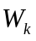 40
Table 7-2 – Conditions and actions for fast AMP mode evaluation 47
Table 7-3. Configuration options for rate control algorithm. 53

Introduction
This document provides an overview of the coding tools defined in HEVC Version 1 and the Range Extension (RExt) of HEVC Version 2, both of which are implemented in the seventh point release of the 16th HEVC test model (HM-16.7). In addition, some of the algorithms that the HM-16.7 encoder uses to control these tools and user-controlled configuration options are also described.

Overview of coding structures
HEVC is a block-based hybrid coding architecture, combining inter and intra prediction and transform coding with high-efficiency entropy coding. However, in contrast to previous video coding standards, HEVC employs a quad-tree coding block partitioning structure that enables a flexible use of large and small coding, prediction, and transform blocks. HEVC also allows for improved intra prediction and coding, adaptive motion parameter prediction and coding, a new loop filter and an enhanced version of context-adaptive binary arithmetic coding (CABAC) entropy coding over that defined by previous standards. New high level structures have also been designed to aid parallel processing.
Figure 1-1 shows a general block diagram of the HM encoder.
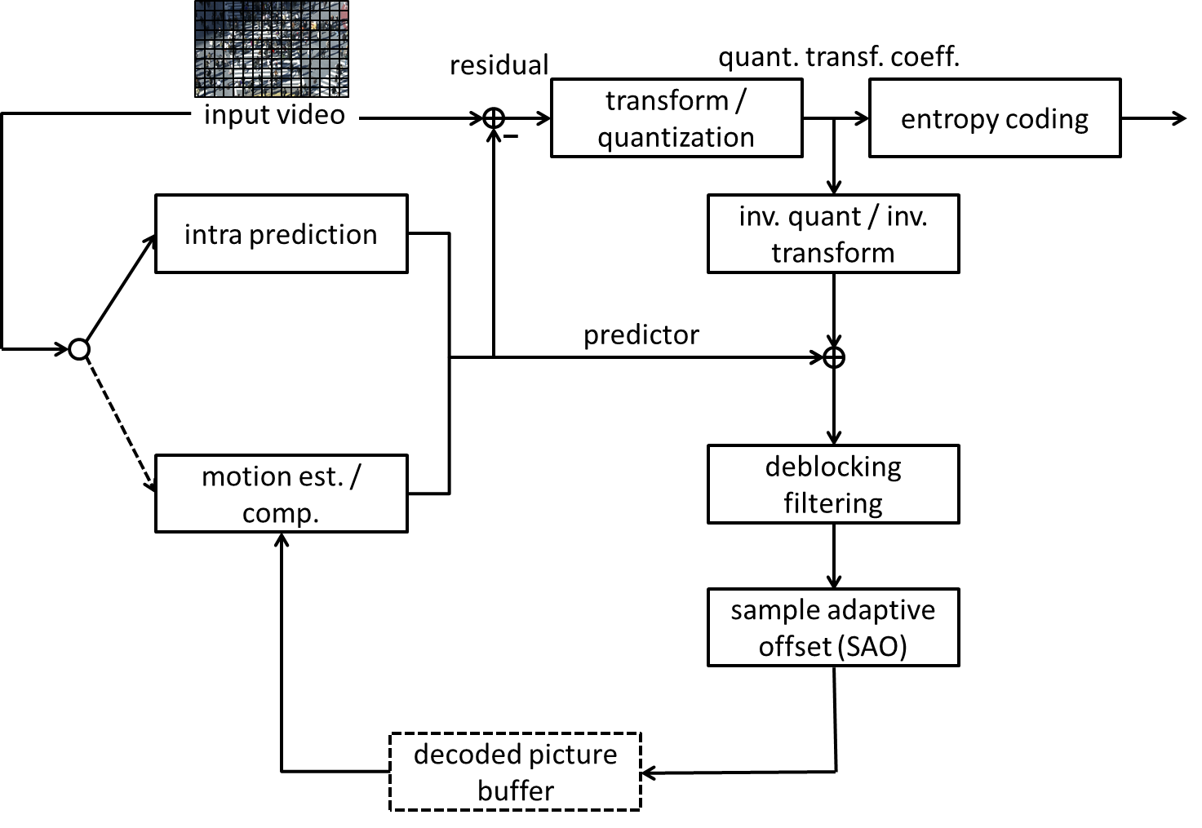
Figure 1-1 – Simplified block diagram of HM encoder
The picture partitioning structure, which is further described in Section 4.1, divides the input video into blocks called coding tree units (CTUs). These CTUs have a role that is broadly analogous to that of macroblocks in previous standards. A CTU is split using a quad-tree into coding units (CUs), with a leaf coding unit (CU) defining a region sharing the same prediction mode (intra, inter or skip). The leaf CU also defines the shape of prediction units (PUs) present, with each PU detailing the prediction information to be used for the respective picture region. Leaf CUs also define another quad-tree that defines the residual-quad-tree (RQT) containing transform units (TUs), which define a region sharing the same transformation and quantization process. The term ‘unit’ defines a region of an image covering all components; the term ‘block’ is used to define a region covering a particular component (e.g. luma), and may differ in spatial location when considering chroma sub-sampling such as 4:2:0.
The intra prediction processes, which are further described in Section 4.1, provide 35 modes (Planar, DC and 33 angular directions) for the luma of each PU, one of which is selected according to the intra prediction mode of a prediction block. Mode-dependent reference and prediction sample smoothing is applied to increase prediction efficiency and intra prediction mode is coded using either one of the three most probable modes (MPM) or one of the 32 remaining modes.
The inter picture prediction processes, which are further described in Section 4.4, select the motion parameters, which includes the option of a skip mode, a merge mode, with motion vectors being coded relative to predictors and able to describe offsets with ¼ pixel accuracy.
The transform and quantization processes, which are further described in Section 4.5, take the residuals generated by subtracting the prediction from the input and spatially transform and quantize them. In the transform process, matrices which are approximations to the DCT are used. In the case of 4x4 intra predicted residuals, an approximation to DST is used for the luma. For 8-bit video, 52-level quantization steps are permitted (the number of steps increases by 6 for each additional video bit depth). Reconstructed samples are created by inverse quantization and inverse transform.
Entropy coding, which is described in Section 4.9, is applied to the generated symbols and quantized transform coefficients in the encoding process using a Context-based Adaptive Binary Arithmetic Coding (CABAC) process.
Loop filtering is described in Section 4.11, which applies two in-loop filtering processes (namely deblocking filtering and sample adaptive offset (SAO) filtering) after the reconstructed pixel data is formed. The resulting image is stored in the decoded picture buffer (DPB) and may be used for inter coding predictions for future frames in coding order.

Obtaining the HEVC test model
The current version of the 16th HEVC test model (HM-16.7) is available from the following locations:
https://hevc.hhi.fraunhofer.de/svn/svn_HEVCSoftware/tags/HM-16.7
https://hevc.hhi.fraunhofer.de/trac/hevc/browser/tags/HM-16.7

Obtaining the HEVC Standard
The HEVC Standard may be obtained from the ISO/IEC and ITU Standards bodies. The document prepared by the JCT-VC for consideration of Version 2 by ISO/IEC/MPEG and ITU/SG16-Q6[VCEG], which includes the Range Extension, can be found at:
http://phenix.int-evry.fr/jct/doc_end_user/documents/18_Sapporo/wg11/JCTVC-R1013-v6.zip

Scope
This document provides an encoder-side description of the HEVC test model 16 (HM), which serves as a tutorial on the encoding algorithms implemented in the HM software. The purpose of this text is to establish a common understanding on reference encoding methods supported in the HM software, in order to facilitate the assessment of the technical impact of proposed new technologies during the HEVC standardization process. Although brief descriptions of the HEVC design are provided to help understanding of the HM, the corresponding sections of the HEVC draft specification [3] should be referred to for any descriptions regarding normative processes. Document [2] provides a summary of configuration options for the HM encoder, without going into detail of encoder algorithms. Documents [4] and [5] define the common test conditions and software reference configurations that should be used for experimental work.

Encoder control of the HEVC test model 16

Encoder configuration options

File, format and profile/level/tier configuration options
Configuration options for the HEVC test model 16 associated with files, formats and profiles/levels/tiers are described in the JCTVC HM software manual [2].

Coding tool configuration options
Table 3-2 provides a list of encoder configuration options for the HEVC test model 16 associated with coding tools.
Table 33-2 – Encoder configuration options for control of coding tools.
Configuration option | Section reference
AlignCABACBeforeBypass | 4.8.1
ChromaFormatIDC | 4.1
CostMode | 6.11
CrossComponentPrediction | 4.10
ExplicitResidualDPCM | 4.7
ExtendedPrecision | 4.5.8
GolombRiceParameterAdaptation | 4.9.3
HighPrecisionPredictionWeighting | 4.4.4.1
ImplicitResidualDPCM | 4.7
IntraReferenceSmoothing | 4.3.2
LowerBitRateConstraintFlag | 5
MaxBitDepthConstraint | 5
MaxCUChromaQpAdjustmentDepth | 4.5.9
MaxCUWidth | 4.2.3
MaxCUHeight | 4.2.3
MaxCUSize | 4.2.3
MaxPartitionDepth | 4.2.3
QuadtreeTULog2MaxSize | 4.2.5
QuadtreeTULog2MinSize | 4.2.5
QuadtreeTUMaxDepthIntra | 4.2.5
QuadtreeTUMaxDepthInter | 4.2.5
ReconBasedCrossCPredictionEstimate | 4.10
ResidualRotation | 4.9.1
SaoLumaOffsetBitShift | 4.11.3
SaoChromaOffsetBitShift | 4.11.3
SingleSignificanceMapContext | 4.9.2
TransformSkipLog2MaxSize | 4.5

Slice coding parameters
Table 33-3 – Encoder configuration options for slice coding.
SliceMode | 6.3
SliceArgument | 6.3
SliceSegmentMode | 6.3
SliceSegmentArgument | 6.3
WaveFrontSynchro | 4.12
TileUniformSpacing | 6.3
NumTileColumnsMinus1 | 6.3
NumTileRowsMinus1 | 6.3
TileColumnWidthArray | 6.3
TileRowHeightArray | 6.3

Motion search options
Table 33-4 – Encoder configuration options for motion search.
DisableIntraInInter | 6.8.2
FastSearch | 6.8.2
SearchRange | 6.8.2
BipredSearchRange | 6.8.2
MinSearchWindow | 6.8.2
RestrictMESampling | 6.8.2
ClipForBiPredMEEnabled | 6.8.2
FastMEAssumingSmootherMVEnabled | 6.8.2
HadamardME | 6.8.2
ASR | 6.8.2

Mode decision parameters
Table 33-5 – Encoder configuration options for mode decisions.
LambdaModifier0 | 6.5.5
LambdaModifier1 | 6.5.5
LambdaModifier2 | 6.5.5
LambdaModifier3 | 6.5.5
LambdaModifier4 | 6.5.5
LambdaModifier5 | 6.5.5
LambdaModifier6 | 6.5.5
LambdaModifierI | 6.5.5
IQPFactor | 6.5.5

Rate control parameters
Table 33-5 – Encoder configuration options for rate control.
RateControl | 6.4
TargetBitrate | 6.4
KeepHierarchicalBit | 6.4
LCULevelRateControl | 6.4
RCLCUSeparateModel | 6.4
InitialQP | 6.4
RCForceIntraQP | 6.4
RCCpbSaturation | 6.4.1
RCCpbSize | 6.4.1
RCInitialCpbFullness | 6.4.1

SEI message configuration options
SEI message configuration options are described in [2].

Overview of tools in HEVC Version 1 and HEVC Version 2 RExt

High level syntax
This section summarizes the main features of the high level syntax of HEVC. A more detailed overview of the topic is provided in a tutorial paper [7].

Bitstream organization
Any bitstream compliant with HEVC is organized into network abstraction layer (NAL) units, which are self-contained packets that allow the video layer to be identical for different transmission environments. Each NAL unit should not exceed the maximum transfer unit size associated with the transmission environment and can be of two types: video coding layer (VCL) and non-video coding layer (non-VCL). The former type carries information associated with coded video data while the latter contains data shared by different pictures. A NAL unit consists of a header, followed by the NAL unit payload. The header has a fixed two byte length, facilitating processing by media aware network elements. Finally, each NAL unit is associated with a particular temporal layer, as indicated by the TemporalId. HEVC mandates that all NAL units associated with a particular picture have the same TemporaId, hence a picture has one and only one TemporalId. Moreover, the syntax of HEVC prohibits any data dependency on data belonging to a higher temporal sublayer when decoding the data associated with a lower temporal sublayer. This restriction is needed to support temporal scalability, as a decoder capable of decoding at a given frame rate is expected to discard NAL units associated with intermediate pictures used for higher frame rate decoding.

Parameter sets
HEVC specifies parameter sets to allow for bitstream robustness over unreliable transmission links. Parameter sets contain information associated with a frame, a coded video sequence (CVS) or shared among several layers. Each parameter set is contained in a non-VCL NAL unit and can be duplicated or transmitted via a separate, reliable, channel to improve bitstream error robustness. HEVC specifies three parameter sets:
- Video parameter set (VPS): Contains information applicable to multiple layers, avoiding replication in each layer. Examples of information contained in the VPS are: profile, level and Hypothetical Reference Decoder (HRD) parameters.
- Sequence parameter set (SPS): Contains information applicable to all slices of a CVS. Examples of information conveyed by the SPS are: picture size, profile and level.
- Picture parameter set (PPS): Contains information which may vary on a per-picture basis. Examples of information contained in the PPS are: quantization parameter and flags indicating the use of particular coding tools (e.g. Transform Skip).
Parameter sets may reference other parameter sets, specifically, a PPS has an ID indicating the associated SPS and an SPS has an ID indicating the associated VPS. Regardless of these associations, to facilitate parsing robustness, each parameter set can be parsed independently, i.e. there is no conditional dependency in the syntax parsing on information present in any associated parameter set.

Picture types
Random access functionality is provided using intra random access point (IRAP) pictures. An IRAP picture can only contain one or more I-slices. HEVC defines three types of IRAP. These three picture types are:
- Instantaneous decoding refresh (IDR)
- Clean random access (CRA)
- Broken link access (BLA)
An IDR picture, when encountered, results in flushing of the decoded picture buffer (DPB). IDR pictures provide RAP functionality but sacrifice coding performance because frames decoded prior to an IDR picture are no longer available for reference in inter coding. In order to allow random access to the content and maintain the coding performance, HEVC defines CRA pictures. CRA pictures are intra coded but, when encountered, do not empty the DPB. Consequently, pictures following a CRA picture in decoding order can still use reference pictures that precede the CRA picture in decoding order. A CRA picture may have leading pictures which can either be decoded or skipped, depending on whether there is a RAP break in the bit stream random access at the CRA picture. Pictures following a CRA in decoding order and correctly decodable are called random access decodable leading (RADL) while pictures following a CRA in decoding order but cannot be correctly decoded without preceding reference frames having been decoded are called random access skipped leading (RASL). One example use case for this functionality is splicing bitstreams to insert advertisements in a television programme. Consider the case when Bitstream 1 (B1) and Bitstream 2 (B2) are concatenated as B1·B2 and the picture which starts the segment associated to B2 is a CRA. All RASL pictures following the CRA picture in decoding order in B2 cannot be correctly decoded because their associated reference pictures are not present in the DPB. These RASL pictures should be discarded from the decoder output and this is accomplished by the splicing operation declaring the CRA picture in B2 to be a BLA picture. In this case the decoder knows that all RASL associated with this BLA picture will not be displayed.

Finally, HEVC also defines two additional types of pictures to support temporal scalability:
- Temporal sublayer access (TSA)
- Step-wise temporal sub-layer access (STSA)
These pictures impose restrictions on the reference used between different temporal layers so that temporal down-switching and up-switching operations can be made possible (see Figure 5 in [7] for an example on the use of TSA and STSA pictures).

Reference picture set
The reference picture set (RPS) has been introduced in HEVC to handle reference pictures in the DPB. In fact, when a picture is no longer used for reference by other pictures, it should be discarded from the DPB. If instead a picture is used as reference for future pictures it must be kept in the DPB to correctly decode the bitstream. The RPS contains information on the status of the DPB and may be signalled in the SPS, and additionally signalled, or overridden, in the slice header. The signalling is absolute, i.e. each RPS describes the DPB status and does not refer to any previous status for its description. In this way, bitstream error resilience is improved even when some NAL units are lost.

Picture partitioning

Coding tree unit (CTU) partitioning
Pictures are divided into a sequence of coding tree units (CTUs), all being the same size, and each covering a square pixel region of the picture. An example of a picture divided into CTUs is shown in Figure 4-1. The size of a CTU is specified with respect to the luma channel, to prevent ambiguity when considering chroma formats.
The size of the CTU is configured as one of 16x×6, 32×32 or 64×64 luma samples.
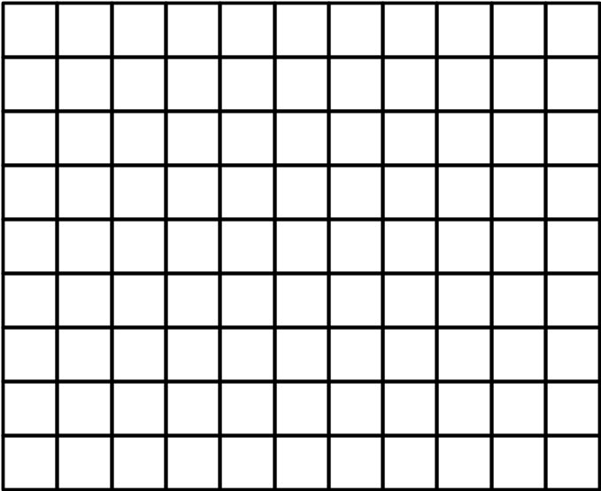
Figure 4-1 – Example of a picture divided into CTUs.

Slice and tile structures
A slice is a data structure that can be decoded independently from other slices of the same picture, in terms of entropy coding, signal prediction, and residual signal reconstruction. A slice can either be the entire picture or a region of a picture, which is not necessarily rectangular. A slice consists of a sequence of one or more slice segments starting with an independent slice segment and containing all subsequent dependent slice segments (if any) that precede the next independent slice segment (if any) within the same access unit.
A slice segment consists of a sequence of CTUs. An independent slice segment is a slice segment for which the values of the syntax elements of the slice segment header are not inferred from the values for a preceding slice segment. A dependent slice segment is a slice segment for which the values of some syntax elements of the slice segment header are inferred from the values for the preceding independent slice segment in decoding order. For dependent slice segments, prediction can be performed across dependent slice segment boundaries, and entropy coding is not initialized at the starting of the dependent slice segment parsing process.
An example of picture with 11 by 9 CTUs that is partitioned into two slices is shown in Figure 4-2, below. In this example, the first slice is composed of an independent slice segment containing 4 CTUs, a dependent slice segment containing 32 CTUs, and another dependent slice segment containing 24 CTUs. The second slice consists of a single independent slice segment containing the remaining 39 CTUs of the picture.
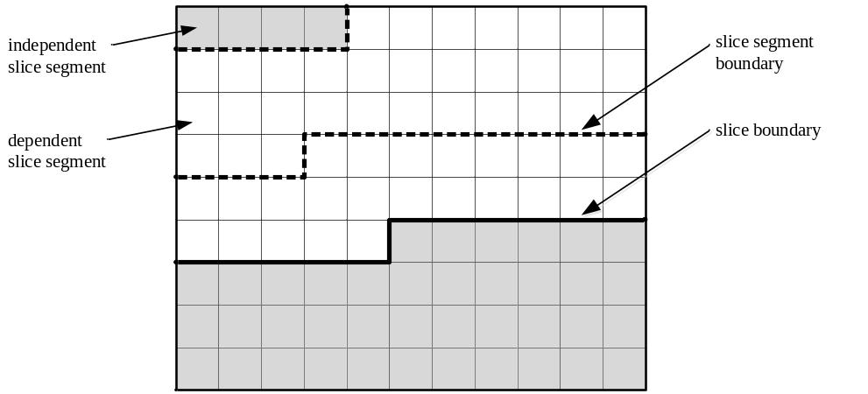
Figure 4-2 – Example of slices and slice segments
A tile is a rectangular region containing an integer number of CTUs. CTUs are ordered in raster scan within a tile, and tiles in a picture are ordered consecutively in a raster scan of the tiles of the picture. This defines the coding order of CTUs, which is referred to as the tile scan order.
A tile may consist of CTUs contained in more than one slice. Similarly, a slice may consist of CTUs contained in more than one tile. Note that within the same picture, there may be both slices that contain multiple tiles and tiles that contain multiple slices. However, one or both of the following conditions must be fulfilled for each slice and tile:
– All coding tree units in a slice belong to the same tile.
– All coding tree units in a tile belong to the same slice.
In addition, one or both of the following conditions must be fulfilled for each slice segment and tile:
– All coding tree units in a slice segment belong to the same tile.
– All coding tree units in a tile belong to the same slice segment.
Two examples of possible slice and tile structures for a picture with 11 by 9 coding tree units are shown in Figure 4-3, below. In both examples, the picture is partitioned into two tiles, separated by a vertical tile boundary. The left-hand example shows a case in which the picture only contains one slice, starting with an independent slice segment and followed by four dependent slice segments. The right-hand example illustrates an alternative case in which the picture contains two slices in the first tile and one slice in the second tile.
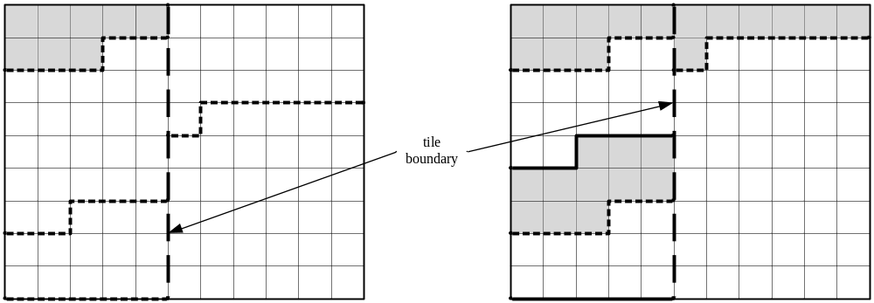
Figure 4-3 – Examples of tiles and slices

Coding unit (CU) and coding tree structure
The coding unit (CU) is a square region (in terms of pixels/luma-samples), and is a node of the quad-tree partitioning of the CTU. The quad-tree partitioning structure allows recursive splitting into four equally sized nodes, starting from the CTU and stopping when no further splitting is signalled in the bit stream (as determined by an encoder) or when the minimum CU size is reached. The minimum CU size is configured in the SPS to be 32×32, 16×16, or 8×8 luma samples; 8×8 is used in the common test conditions [4] and [5] for HEVC development. Each leaf node CU is configured to use a particular prediction mode, that being either intra prediction or inter-prediction. Figure 4-4 shows a CTU divided into multiple CUs.
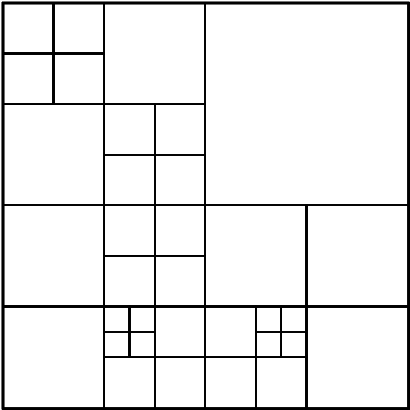
Figure 4-4 – Example of coding tree structure
The quad-tree partitioning thus allows a content-adaptive coding tree structure comprised of CUs, each of which may be as large as the CTU or as small as 8×8.
The CTU size and minimum CU size are configured using the syntax elements log2_min_luma_coding_block_size_minus3 and log2_diff_max_min_luma_coding_block_size. The HM Encoder sets these syntax elements according to MaxCUWidth, MaxCUHeight, MaxCUSize and MaxPartitionDepth. The maximum partition depth is defined as the maximum number of splits in the CU quad-tree and one split resulting from dividing a CU into partitions for prediction (to be described below). Thus, a CTU size of 64×64 and a maximum partition depth of 4 implies a minimum CU size of 8×8.

Prediction unit (PU) structure
Each leaf CU is associated with one or more prediction units (PU) according to a partition mode and all PUs associated with a given CU have the same prediction mode. Each CU includes one, two or four PUs, depending on the partition mode of the CU. Figure 4-5 shows the eight partition modes that may be used to define the PUs for a CU.
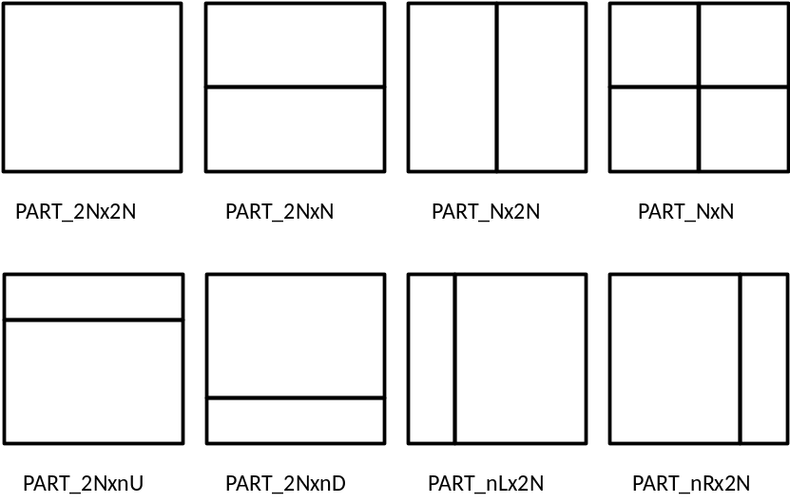
Figure 4-5 – 8 partition modes for inter PU
For a CU configured to use intra prediction, only square PUs are available and thus only partition modes PART_NxN and PART_2Nx2N are available; the latter is only available when the CU size is equal to the configured minimum CU size.
For a CU configured to use inter-prediction, all eight partition modes are available. The availability of non-square PU sizes permits improved matching of boundaries of real objects in the picture. To reduce the worst case memory bandwidth of motion compensation, the 4×4 PU is prohibited and 4×8 and 8×4 PU sizes may only reference one reference picture. Other PU sizes can reference one or two reference picture.
A PU spans all colour channels and is generally associated with one prediction block (PB) for each colour channel. The exception being for a 4x4 PU where there may or may not be associated chroma PBs: for 4:2:0 chroma formats, an 8x8 CU that is split into four 4x4 PUs will have four luma PBs, but only one 4x4 PB per chroma channel for intra coded blocks. Fortunately for this exception, it will be seen that the transform block (TB) term is used instead.

Transform unit (TU) and transform tree structure
The transform unit (TU) is a square region of size 8×8, 16×16 or 32×32 luma samples/pixels defined by a quadtree partitioning of a leaf CU. The quadtree partitioning of the CU into one or more TUs is known as a ‘residual quadtree’ (RQT). In general, each TU is associated with one transform block (TB) per colour channel. However, for the 4:2:2 chroma format (permitted in some RExt profiles) there must always be two TBs per chroma channel in order to ensure that the TBs are square (to match the defined transforms). In addition, in all chroma formats, the 8x8 TU may be split into four 4×4 luma TBs, but for the 4:2:0 format, the 8×8 TU will continue to have just one 4x4 chroma-sample (8×8 pixels) TB per chroma channel; similarly two 4x4 chroma-sample (8×4 pixels) TBs per chroma channel for 4:2:2. For 4:4:4, there will be four 4x4 chroma-sample (4×4 pixels) for each chroma channel. Figure 4-6 shows an example RQT.
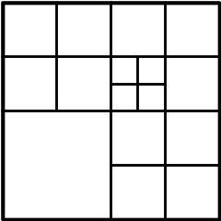
Figure 4-6 – Example of transform tree structure within CU
The range of supported transform sizes is signalled in the bitstream using log2_min_luma_transform_block_size_minus2 and log2_diff_max_min_luma_transform_block_size. These values are specified using QuadtreeTULog2MaxSize and QuadtreeTULog2MinSize.
The maximum depth of the RQT is signalled in the bitstream independently for inter-predicted CUs and intra-predicted CUs using max_transform_hierarchy_depth_inter and max_transform_hierarchy_depth_intra, respectively in the SPS. These values are controlled using QuadtreeTUMaxDepthInter and QuadtreeTUMaxDepthIntra, respectively, in the HM Encoder.
For a CU configured to use inter-prediction, PU boundaries may occur within a given TU. For a CU configured to use intra prediction, PU boundaries cannot occur within a given TU, except for when an 8×8 TU is split into four 4×4 luma TBs (which effectively makes a virtual TU of 4×4 luma samples, with 4×4 luma samples also being the smallest PU size).

Intra prediction

Prediction modes
Intra prediction involves producing samples for a given TB using samples previously reconstructed in the considered colour channel. The intra prediction mode is separately signalled for the luma and chroma channels, with the chroma channel intra prediction mode optionally dependant on the luma channel intra prediction mode via the ‘DM_CHROMA’ mode. Although the intra prediction mode is signalled at the PB level, the intra prediction process is applied at the TB level, in accordance with the residual quad-tree hierarchy for the CU, thereby allowing the coding of one TB to have an effect on the coding of the next TB within the CU, and therefore reducing the distance to the samples used as reference values.
HEVC includes 35 intra prediction modes – a DC mode, a planar mode and 33 directional, or ‘angular’ intra prediction modes. The 33 angular intra prediction modes are illustrated in Figure 4-7 below.
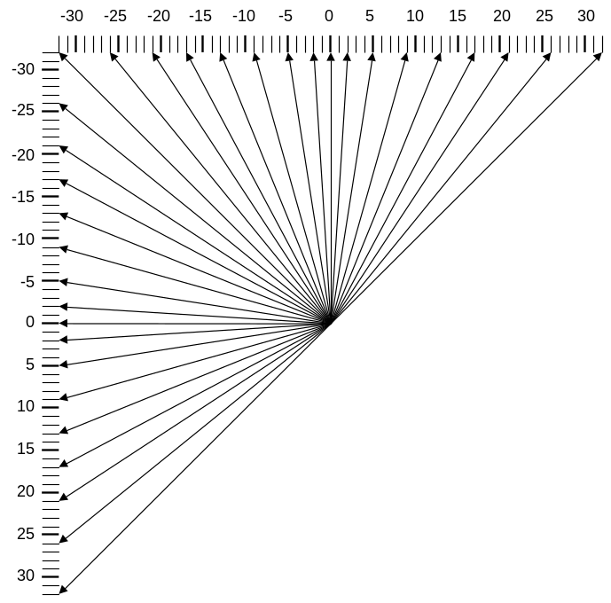
Figure 4-7 – The 33 intra prediction directions
The mapping between the direction of each of the angular intra prediction modes and the intra prediction mode number is specified in Figure 4-8, below.
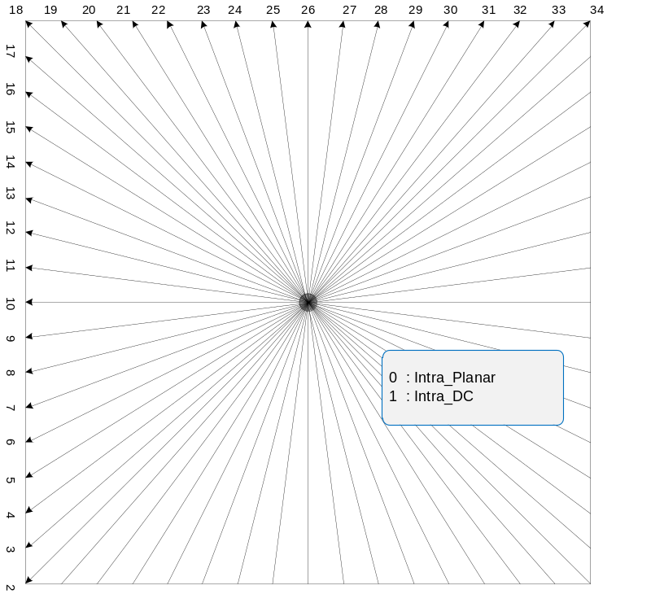
Figure 4-8 – Mapping between intra prediction direction and intra prediction mode
For PBs associated with chroma colour channels, the intra prediction mode is specified as either planar, DC, horizontal, vertical, ‘DM_CHROMA’ mode or sometimes diagonal mode ‘34’. Table 4-1 shows the rule specifying the chroma colour channel PB intra prediction mode given the luma colour channel PB intra prediction mode and the ‘intra_chroma_pred_mode’ syntax element.
Note for chroma formats 4:2:2 and 4:2:0, the chroma PB may overlap two or four (respectively) luma PBs; in this case the luma direction for DM_CHROMA is taken from the top left of these luma PBs.
The DM_CHROMA mode indicates that the intra prediction mode of the luma colour channel PB is applied to the chroma colour channel PBs. Since this is relatively common, the most-probable-mode coding scheme of the intra_chroma_pred_mode is biased in favour of this mode being selected.
Table 44-1 – Mapping between intra prediction direction and intra prediction mode for chroma
intra_chroma_pred_mode | Luma intra prediction direction, X
intra_chroma_pred_mode | 0 | 26 | 10 | 1 | Otherwise ( 0 <= X <= 34 )
0 | 34 | 0 | 0 | 0 | 0
1 | 26 | 34 | 26 | 26 | 26
2 | 10 | 10 | 34 | 10 | 10
3 | 1 | 1 | 1 | 34 | 1
4 (DM_CHROMA) | 0 | 26 | 10 | 1 | X

Filtering of neighbouring samples
The neighbouring samples filtering process for intra prediction is skipped when intra_smoothing_disabled_flag is set to 1 (as configured by the IntraReferenceSmoothing enable flag). The intra reference smoothing filter is disabled in common test conditions [5] only when sequence-level lossless coding is used.
If the intra reference smoothing filter is enabled, then for the luma component, the neighbouring samples used for generation of intra-predicted samples are filtered. The filtering further is controlled by the given intra prediction mode and transform block size. If the intra prediction mode is DC or the transform block size is equal to 4×4, neighbouring samples are not filtered. If the distance between the given intra prediction mode and vertical mode (or horizontal mode) is larger than predefined threshold, the filtering process remains enabled (otherwise the filtering process becomes disabled). The predefined threshold is specified in Table 4-2, where nT represents the TB size.
Table 44-2 – Specification of predefined threshold for various transform block sizes
 | nT = 8 | nT = 16 | nT = 32
Threshold | 7 | 1 | 0
If filtering remains enabled, then either a neighbouring sample filtering, [1, 2, 1] or a bi-linear filter are used. The bi-linear filtering is used if all of the following conditions are true (otherwise the neighbouring sample filtering is used):
– strong_intra_smoothing_enabled_flag is equal to 1
– luma channel under consideration
– transform block size is equal to 32
– Abs( p[ −1 ][ −1 ] + p[ nT*2−1 ][ −1 ] – 2*p[ nT−1 ][ −1 ] ) < (1 << ( BitDepthY − 5 ))
– Abs( p[ −1 ][ −1 ] + p[ −1 ][ nT*2−1 ] – 2*p[ −1 ][ nT−1 ] ) < (1 << ( BitDepthY − 5 ))

Intra boundary filter
When reconstructing intra-predicted TBs an intra-boundary filter (IBF) may be used when predicting samples along the left and/or top edges of the TB for PBs using horizontal, vertical and DC intra prediction modes, as shown in Figure 4-9. For horizontal and vertical intra prediction modes, the IBF is disabled when implicit RDPCM and transquant bypass are enabled. For the DC intra prediction mode, the IBF is applied to the luma channel of TBs smaller than 32×32.
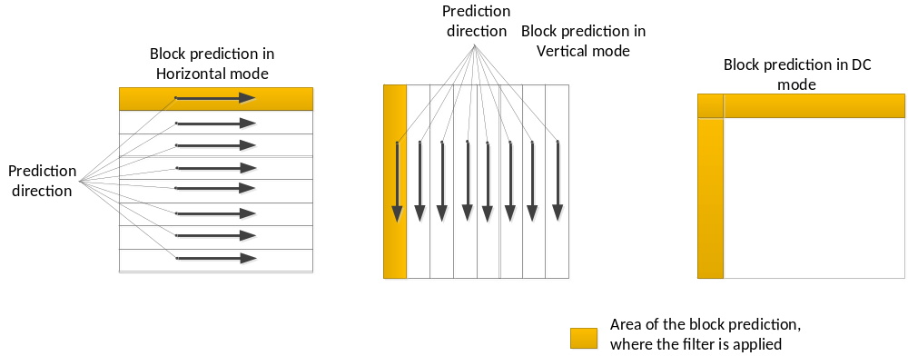
Figure 4-9 – Intra boundary filter example.
The intra boundary filter is defined with respect to an array of predicted samples p as input and predSamples as output as follows:
– For horizontal intra-prediction applied to luma transform blocks of size less than 32×32, and disableIntraBoundaryFilter is equal to 0, the following filtering applies with x = 0..nTbS − 1, y = 0:
predSamples[ x ][ y ] = Clip1_{Y}( p[ −1 ][ y ] + ( ( p[ x ][ −1 ] − p[ −1 ][ −1 ] ) >> 1 ) )
– For vertical intra-prediction applied to luma transform blocks of size less than 32x32, and disableIntraBoundaryFilter is equal to 0, the following filtering applies with x = 0..nTbS − 1, y = 0:
predSamples[ x ][ y ] = Clip1_{Y}( p[ x ][ −1 ] + ( ( p[ −1 ][ y ] − p[ −1 ][ −1 ] ) >> 1 ) )
– For DC intra-prediction applied to luma transform blocks of size less than 32x32 the following filtering applies with x = 0..nTbS − 1, y = 0 (where dcVal is the DC predictor):
predSamples[ 0 ][ 0 ] = ( p[ −1 ][ 0 ] + 2 * dcVal + p[ 0 ][ −1 ] + 2 ) >> 2
predSamples[ x ][ 0 ] = ( p[ x ][ −1 ] + 3 * dcVal + 2 ) >> 2, with x = 1..nTbS − 1
predSamples[ 0 ][ y ] = ( p[ −1 ][ y ] + 3 * dcVal + 2 ) >> 2, with y = 1..nTbS − 1

4:2:2 chroma format mode adjustment
When the DM_CHROMA mode is selected (i.e. intra_chroma_pred_mode is equal to 4) and the 4:2:2 chroma format is in use, the intra prediction mode for a chroma PB is derived from intra prediction mode for the corresponding luma PB and 4:2:0/4:4:4 chroma as specified in Table 4-3.
Table 44-3 – Specification of intra prediction mode for 4:2:2 chroma (Proposal 2)
intra pred mode | 0 | 1 | 2 | 3 | 4 | 5 | 6 | 7 | 8 | 9 | 10 | 11 | 12 | 13 | 14 | 15 | 16 | 17
intra pred mode for 4:2:2 chroma | 0 | 1 | 2 | 2 | 2 | 2 | 2 | 4 | 6 | 8 | 10 | 12 | 14 | 16 | 18 | 18 | 18 | 18
intra pred mode |  | 18 | 19 | 20 | 21 | 22 | 23 | 24 | 25 | 26 | 27 | 28 | 29 | 30 | 31 | 32 | 33 | 34
intra pred mode for 4:2:2 chroma |  | 22 | 22 | 23 | 23 | 24 | 24 | 25 | 25 | 26 | 27 | 27 | 28 | 28 | 29 | 29 | 30 | 30

The result of this mapping table is illustrated in Figure 4-10, which shows the intra prediction angles for the 4:2:2 chroma format.

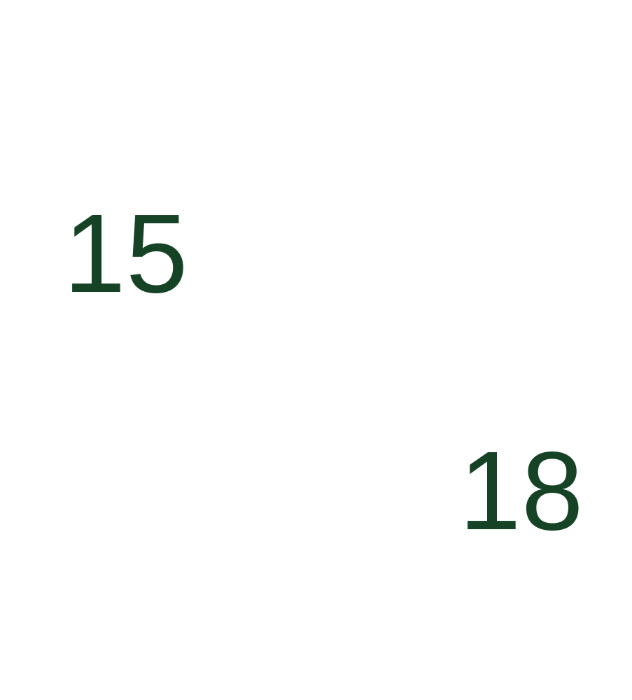
Figure 4-10 – Intra prediction angle for 4:2:2 chroma format.

Inter prediction

Prediction modes
Each inter-predicted PU has a set of motion parameters consisting of one or two motion vectors and reference picture indices and reference picture list usage index to be used for inter-predicted sample generation and signalled in an explicit or implicit manner. When a CU is coded with skip mode, the CU is associated with one PU and has no significant residual coefficients, no coded motion vector delta or reference picture index. A merge mode is specified whereby the motion parameters for the current PU are obtained from neighbouring PUs, including spatial and temporal candidates. The merge mode can be applied to any inter-predicted PU, not only for skip mode. The alternative to merge mode is the explicit transmission of motion parameters, where motion vector, corresponding reference picture index for each reference picture list and reference picture list usage flag are signalled explicitly per each PU. When the reference picture list usage index signals that either one of two reference picture lists is to be used, the PU is produced from one reference block of samples. This mode is referred to as ‘uni-prediction’. For P-slices, this is the only supported mode of operation. When the reference picture list usage index signals both reference picture lists are to be used, the PU is produced from two reference blocks of samples. This mode is referred to as ‘bi-prediction’. The following text provides the details on the inter prediction modes specified in HEVC. The description will start with the merge mode.

Derivation of candidates for merge mode
When a PU is predicted using merge mode, an index pointing to an entry in the merge candidates list is parsed from the bitstream and used to retrieve the motion information. The construction of this list is specified in the HEVC standard and can be summarized according to the following sequence of steps:
- Step 1: Initial candidates derivation
  - Step 1.1: Spatial candidates derivation
  - Step 1.2: Redundancy check for spatial candidates
  - Step 1.3: Temporal candidates derivation
- Step 2: Additional candidates insertion
  - Step 2.1: Creation of bi-predictive candidates
  - Step 2.2: Insertion of zero motion candidates
These steps are also schematically depicted in Figure 4-11. For spatial merge candidate derivation, a maximum of four merge candidates are selected among candidates that are located in five different positions. For temporal merge candidate derivation, a maximum of one merge candidate is selected among two candidates. Since constant number of candidates for each PU is assumed at decoder, additional candidates are generated when the number of candidates does not reach to maximum number of merge candidate (MaxNumMergeCand) which is signalled in slice header. Since the number of candidates is constant, index of best merge candidate is encoded using truncated unary binarization (TU). If the size of CU is equal to 8, all the PUs of the current CU share a single merge candidate list, which is identical to the merge candidate list of the 2N×2N prediction unit.
In the following, the operations associated with the aforementioned steps are detaild.

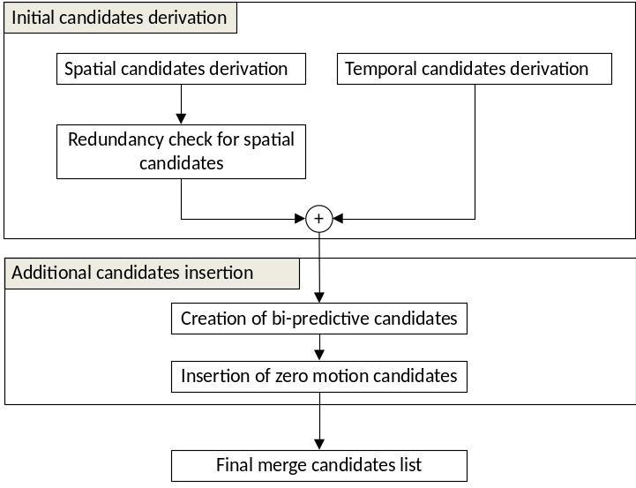
Figure 4-11 – Derivation process for merge candidates list construction

Spatial candidates derivation
In the derivation of spatial merge candidates, a maximum of four merge candidates are selected among candidates located in the positions depicted in Figure 4-12. The order of derivation is A_{1,} B_{1,} B_{0,} A₀ and B₂. Position B₂ is considered only when any PU of position A₁, B₁, B₀, A₀ is not available (e.g. because it belongs to another slice or tile) or is intra coded. After candidate at position A₁ is added, the addition of the remaining candidates is subject to a redundancy check which ensures that candidates with same motion information are excluded from the list so that coding efficiency is improved. To reduce computational complexity, not all possible candidate pairs are considered in the mentioned redundancy check. Instead only the pairs linked with an arrow in Figure 4-13 are considered and a candidate is only added to the list if the corresponding candidate used for redundancy check has not the same motion information. Another source of duplicate motion information is the “second PU” associated with partitions different from 2Nx2N. As an example, Figure 4-14 depicts the second PU for the case of N×2N and 2N×N, respectively. When the current PU is partitioned as N×2N, candidate at position A₁ is not considered for list construction. In fact, by adding this candidate will lead to two prediction units having the same motion information, which is redundant to just have one PU in a coding unit. Similarly, position B₁ is not considered when the current PU is partitioned as 2N×N.

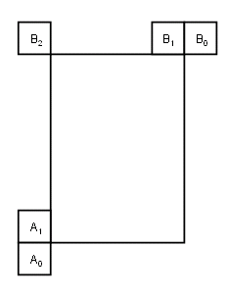
Figure 4-12 – Positions of spatial merge candidate

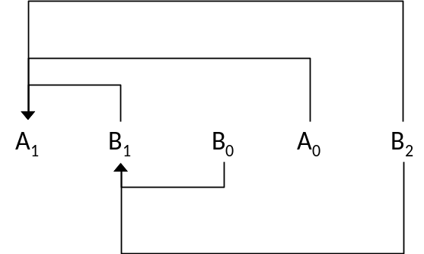
Figure 4-13 – Candidate pairs considered for redundancy check of spatial merge candidates

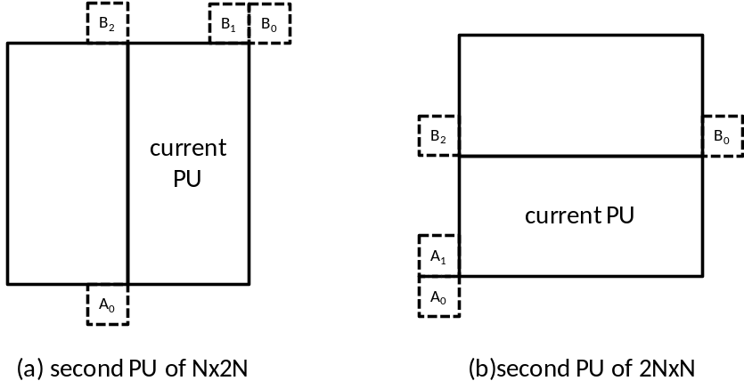
Figure 4-14 – Positions for the second PU of N×2N and 2N×N partitions

Temporal candidates derivation
In this step, only one candidate is added to the list. Particularly, in the derivation of this temporal merge candidate, a scaled motion vector is derived based on co-located PU belonging to the picture which has the smallest POC difference with current picture within the given reference picture list. The reference picture list to be used for derivation of the co-located PU is explicitly signalled in the slice header. The scaled motion vector for temporal merge candidate is obtained as illustrated by the dotted line in Figure 4-15, which is scaled from the motion vector of the co-located PU using the POC distances, tb and td, where tb is defined to be the POC difference between the reference picture of the current picture and the current picture and td is defined to be the POC difference between the reference picture of the co-located picture and the co-located picture. The reference picture index of temporal merge candidate is set equal to zero. A practical realization of the scaling process is described in the HEVC specification [3]. For a B-slice, two motion vectors, one is for reference picture list 0 and the other is for reference picture list 1, are obtained and combined to make the bi-predictive merge candidate.
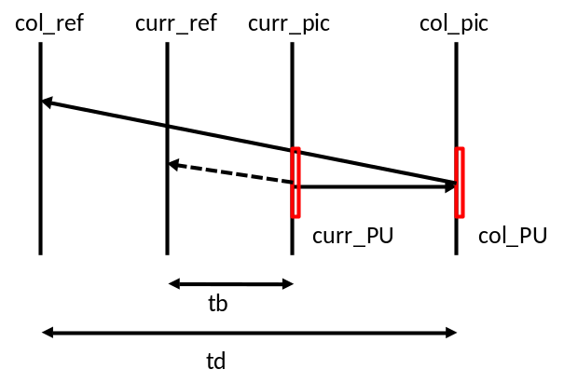
Figure 4-15 – Illustration of motion vector scaling for temporal merge candidate
In the co-located PU (Y) belonging to the reference frame, the position for the temporal candidate is selected between candidates C₀ and C₁, as depicted in Figure 4-16. If PU at position C₀ is not available, is intra coded, or is outside of the current CTU, position C₁ is used. Otherwise, position C₀ is used in the derivation of the temporal merge candidate.
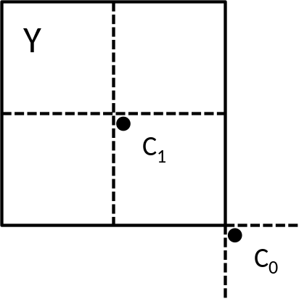
Figure 4-16 – Candidate positions for temporal merge candidate, C₀ and C₁

Additional candidates insertion
Besides spatio-temporal merge candidates, there are two additional types of merge candidates: combined bi-predictive merge candidate and zero merge candidate. Combined bi-predictive merge candidates are generated by utilizing spatio-temporal merge candidates. Combined bi-predictive merge candidate is used for B-Slice only. The combined bi-predictive candidates are generated by combining the first reference picture list motion parameters of an initial candidate with the second reference picture list motion parameters of another. If these two tuples provide different motion hypotheses, they will form a new bi-predictive candidate. As an example, Figure 4-16 depicts the case when two candidates in the original list (on the left), which have mvL0 and refIdxL0 or mvL1 and refIdxL1, are used to create a combined bi-predictive merge candidate added to the final list (on the right). There are numerous rules regarding the combinations which are considered to generate these additional merge candidates, defined in [3].
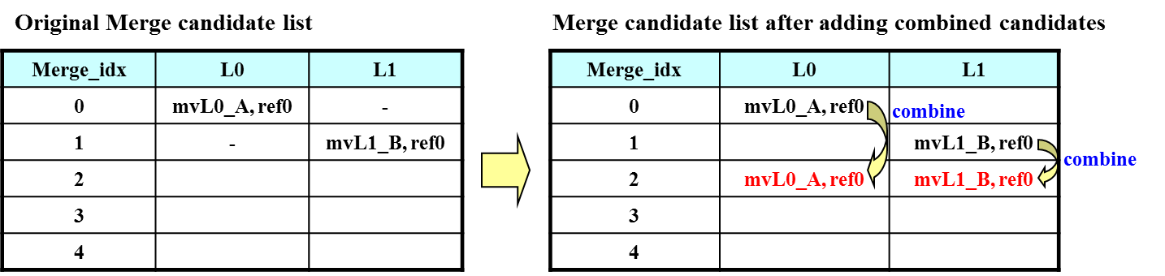
Figure 4-17 – Example of combined bi-predictive merge candidate
Zero motion candidates are inserted to fill the remaining entries in the merge candidates list and therefore hit the MaxNumMergeCand capacity. These candidates have zero spatial displacement and a reference picture index which starts from zero and increases every time a new zero motion candidate is added to the list. The number of reference frames used by these candidates is one and two for uni and bi-directional prediction, respectively. Finally, no redundancy check is performed on these candidates.

Motion estimation regions for parallel processing
To speed up the encoding process, motion estimation can be performed in parallel whereby the motion vectors for all prediction units inside a given region are derived in simultaneously. The derivation of merge candidates from spatial neighbourhood may interfere with parallel processing as one prediction unit cannot derive the motion parameters from an adjacent PU until its associated motion estimation is completed. To mitigate the trade-off between coding efficiency and processing latency, HEVC defines the motion estimation region (MER) whose size is signalled in the picture parameter set using the “log2_parallel_merge_level_minus2” syntax element [3]. When a MER is defined, merge candidates falling in the same region are marked as unavailable and therefore not considered in the list construction.

Motion vector prediction
Motion vector prediction exploits spatio-temporal correlation of motion vector with neighbouring PUs, which is used for explicit transmission of motion parameters. It constructs a motion vector candidate list by firstly checking availability of left, above temporally neighbouring PU positions, removing redundant candidates and adding zero vector to make the candidate list to be constant length. Then, the encoder can select the best predictor from the candidate list and transmit the corresponding index indicating the chosen candidate. Similarly with merge index signalling, the index of the best motion vector candidate is encoded using truncated unary. The maximum value to be encoded in this case is 2 (see Figure 4-18). In the following sections, details about derivation process of motion vector prediction candidate are provided.

Derivation of motion vector prediction candidates
Figure 4-18 summarizes derivation process for motion vector prediction candidate.

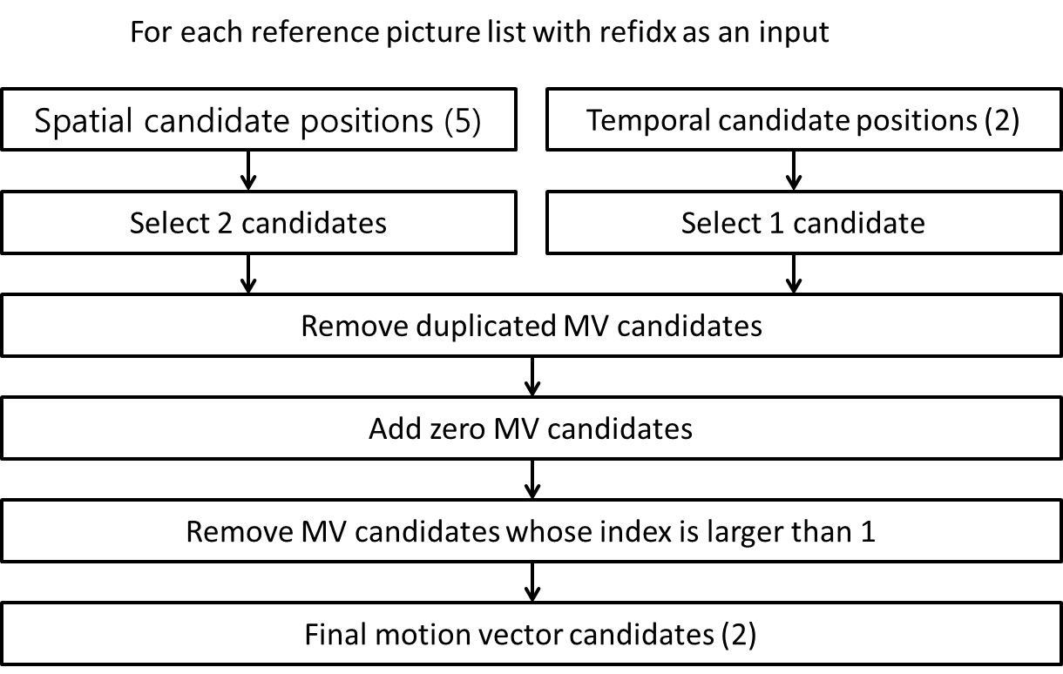
Figure 4-18 – Derivation process for motion vector prediction candidates
In motion vector prediction, two types of motion vector candidates are considered: spatial motion vector candidate and temporal motion vector candidate. For spatial motion vector candidate derivation, two motion vector candidates are eventually derived based on motion vectors of each PU located in five different positions as depicted in Figure 4-14..
For temporal motion vector candidate derivation, one motion vector candidate is selected from two candidates, which are derived based on two different co-located positions. After the first list of spatio-temporal candidates is made, duplicated motion vector candidates in the list are removed. If the number of potential candidates is larger than two, motion vector candidates whose index is larger than 1 are removed from the list. If the number of spatio-temporal motion vector candidates is smaller than two, additional zero motion vector candidates is added to the list.

Spatial motion vector candidates
In the derivation of spatial motion vector candidates, a maximum of two candidates are considered among five potential candidates, which are derived from PUs located in positions as depicted in Figure 4-12, those positions being the same as those of motion merge. The order of derivation for the left side of the current PU is defined as A₀, A₁,and scaled A₀,scaled A₁. The order of derivation for the above side of the current PU is defined as B₀, B₁, B₂, scaled B₀, scaled B₁, scaled B₂. For each side there are therefore four cases that can be used as motion vector candidate, with two cases not required to use spatial scaling, and two cases where spatial scaling is used. The four different cases are summarized as follows.
- No spatial scaling
  - (1) Same reference picture list, and same reference picture index (same POC)
  - (2) Different reference picture list, but same reference picture (same POC)
- Spatial scaling
  - (3) Same reference picture list, but different reference picture (different POC)
  - (4) Different reference picture list, and different reference picture (different POC)
The no-spatial-scaling cases are checked first followed by the spatial scaling. Spatial scaling is considered when the POC is different between the reference picture of the neighbouring PU and that of the current PU regardless of reference picture list. If all PUs of left candidates are not available or are intra coded, scaling for the above motion vector is allowed to help parallel derivation of left and above MV candidates. Otherwise, spatial scaling is not allowed for the above motion vector.
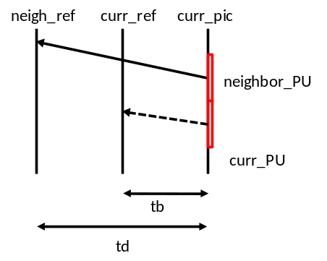
Figure 4-19 – Illustration of motion vector scaling for spatial motion vector candidate
In a spatial scaling process, the motion vector of the neighbouring PU is scaled in a similar manner as for temporal scaling, as depicted as Figure 4-18. The main difference is that the reference picture list and index of current PU is given as input; the actual scaling process is the same as that of temporal scaling.

Temporal motion vector candidates
Apart for the reference picture index derivation, all processes for the derivation of temporal merge candidates are the same as for the derivation of spatial motion vector candidates (see Figure 4-16). The reference picture index is signalled to the decoder.

Interpolation filter
For the luma interpolation filtering, an 8-tap separable DCT-based interpolation filter is used for 2/4 precision samples and a 7-tap separable DCT-based interpolation filter is used for 1/4 precisions samples, as shown in Table 4-4.
Table 44-4 – 8-tap DCT-IF coefficients for 1/4th luma interpolation
Position | Filter coefficients
1/4 | { -1, 4, -10, 58, 17, -5, 1 }
2/4 | { -1, 4, -11, 40, 40, -11, 4, -1 }
3/4 | { 1, -5, 17, 58, -10, 4, -1 }
Similarly, a 4-tap separable DCT-based interpolation filter is used for the chroma interpolation filter, as shown in Table 4-5.
Table 44-5 – 4-tap DCT-IF coefficients for 1/8th chroma interpolation
Position | Filter coefficients
1/8 | { -2, 58, 10, -2 }
2/8 | { -4, 54, 16, -2 }
3/8 | { -6, 46, 28, -4 }
4/8 | { -4, 36, 36, -4 }
5/8 | { -4, 28, 46, -6 }
6/8 | { -2, 16, 54, -4 }
7/8 | { -2, 10, 58, -2 }
For the vertical interpolation for 4:2:2 and the horizontal and vertical interpolation for 4:4:4 chroma channels, the odd positions in Table 4-5 are not used, resulting in 1/4th chroma interpolation.
For the bi-directional prediction, the bit-depth of the output of the interpolation filter is maintained to 14-bit accuracy, regardless of the source bit-depth, before the averaging of the two prediction signals. The actual averaging process is done implicitly with the bit-depth reduction process as:
predSamples[ x, y ] = ( predSamplesL0[ x, y ] + predSamplesL1[ x, y ] + offset ) >> shift
where
shift = ( 15 – BitDepth ) and offset = 1 << ( shift – 1 )

Weighted Prediction
A weighted prediction (WP) tool is provided by HEVC. WP corresponds to the equivalent tool present in AVC and is intended to improve the performance of inter prediction when the source material is subject to illumination variations, e.g. when using fading or cross-fading. It should be noted that WP is not enabled in the HM common test conditions [4] and [5].
The principle of WP is to replace the inter prediction signal P by a linear weighted prediction signal P’ (with weight w and offset o):
Uni-prediction: P’ = w × P + o
Bi-prediction: P’ = (w0 × P0 + o0 + w1 × P1 + o1) / 2
The applicable weights and offsets are selected by the encoder and are conveyed within the bitstream. L0 and L1 suffixes define List0 and List1 of the reference pictures list, respectively. Bit depth is maintained to 14 bit accuracy (in HEVC Version 1) before averaging the prediction signals, as for interpolation filters.
In the case of bi-prediction with at least one reference picture available in each list L0 and L1, the following formula applies to the explicit signalling of weighted prediction parameters relating to the luma channel:
predSamples[ x ][ y ] =
Clip3( 0, ( 1 << bitDepth ) − 1, ( predSamplesL0 [ x ][ y ] * w0 + predSamplesL1[ x ][ y ] * w1 + ( (o0 + o1 + 1) << log2WD) ) >> (log2WD + 1) )
where
log2WD = luma_log2_weight_denom + 14 - bitDepth
w0 = LumaWeightL0[ refIdxL0 ], w1 = LumaWeightL1[ refIdxL1 ]
o0 = luma_offset_l0[ refIdxL0 ] * highPrecisionScaleFactor
o1 = luma_offset_l1[ refIdxL1 ] * highPrecisionScaleFactor
highPrecisionScaleFactor = (1 << ( bitDepth – 8 ) ) (except see Section 3.3.4.1)
A corresponding formula applies to the chroma channel and to the case of uni-prediction.

High precision offsets
A highPrecisionScaleFactor of ( 1 << ( bitDepth – 8 ) ) is applied to the weighted prediction offsets o0 and o1 when high_precision_offsets_enabled_flag is equal to zero. At higher bit depths, this factor increases in magnitude, reducing the performance of weighted prediction.
When the high_precision_offsets_enabled_flag is equal to one (permitted in RExt profiles), the offsets (o0 and o1) have the same precision as the input (i.e. the factor above is removed) in order to provide enough precision for the weighted prediction process.
The high_precision_offsets_enabled_flag is configured by HighPrecisionPredictionWeighting in the encoder.

Transform and quantization (scaling)
In HEVC, each TB (which are 4×4, 8×8, 16×16 or 32×32 samples) is transformed, transform skipped or coded losslessly via a trans-quant-bypass mode.
The scaling and transformation processes at the decoder side for a transformed block are shown in Figure 4-19.
Figure 4-20 – Lossless scaling and transformation process (quantities illustrated for HEVC version 1 profiles)..
When transform skip (TS) is used, a bit-shift is applied instead of a transform. TS may be applied to 4×4 TBs for Main/Main10 profiles and TBs of any size for format range extensions profiles. In this case, the scaling and transformation processes at the decoder side are as shown in Figure 4-20.
Figure 4-21 – Transform skip scaling and transformation process (quantities illustrated for HEVC version 1 profiles)..
For the format range extensions profiles, transform skip is supported on all TU sizes. The maximum sized TU for which transform skip is available is signaled by log2_max_transform_skip_block_size_minus2 (as configured by TransformSkipLog2MaxSize)
If lossless mode is used, scaling and transformation process at the decoder side are as follows.
r[ x ][ y ] = TransCoeffLevel[ x ][ y ]

Inverse transforms
The inverse transform is implemented as a vertical 1D transformation step operating on each column of residual coefficients (i.e. d[ x ][ y ]), following by a clipping step operating on the output of the vertical 1D transformation step (i.e. e[ x ][ y ]) and finally a horizontal 1D transformation step operating on each row of the output of the clipping step (i.e. g[ x ][ y ]). This process is illustrated in Figure 4-21 for HEVC version 1 profiles. The clipping of intermediate sample values g[ x ][ y ] ensures that these values can be represented with 16 bits.
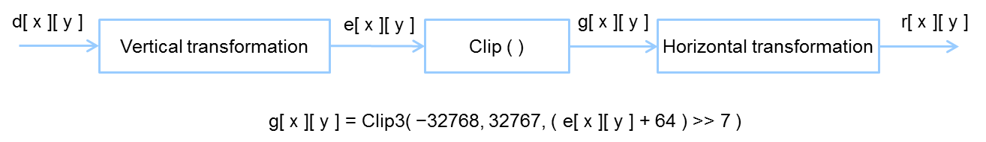
Figure 4-22 – Inverse transformation process (quantities illustrated for HEVC version 1 profiles).

1D inverse transform matrices
The transform matrices are an approximation of mathematical DCT matrices with 8-bit integers (including sign), utilizing 6 bits of fractional accuracy. The matrices have been optimized for maximizing orthogonality. Smaller size transform matrices are embedded in larger size transform matrices, enabling reuse of a 32×32 matrix when performing 4×4, 8×8, 16×16, and 32×32 transforms.
A 4×4 DST is also provided and is used only for residuals of all 4×4 intra-predicted luma TBs.
In the HM implementation, the transform is applied using a partial butterfly structure for low computational complexity.

Scaling and quantization
The quantized transform coefficients q_{ij} (i, j=0..nS-1) are derived from the transform coefficients d_{ij} (i, j=0..nS-1) as
q_{ij} = ( d_{ij} * f[QP%6] + offset ) >> ( 29 + QP/6 – nS – BitDepth), with i,j = 0,...,nS-1
where
f[x] = {26214,23302,20560,18396,16384,14564}, x=0,…,5
2^{28+QP/6–nS-BitDepth} < offset < 2^{29+QP/6–nS-BitDepth}

Scaling lists
Scaling lists (c.f. quantization matrices) can be applied during the (inverse) quantization process. The scaling values are signalled in the PPS, and each possible TB size, colour component and prediction type (intra/inter) can have its own scaling list, except for 32×32 chroma blocks, which is used only for the 4:4:4 RExt chroma format. For 16×16 and 32x32 scaling lists, the scaling lists are specified with an 8x8 grid of values which is value-repeated to the required size, along with a value used for the entry corresponding to the DC frequency location.
The scaling list for 32×32 chroma blocks is derived from the 16×16 chroma scaling list. This derivation is shown in Figure 4-23.
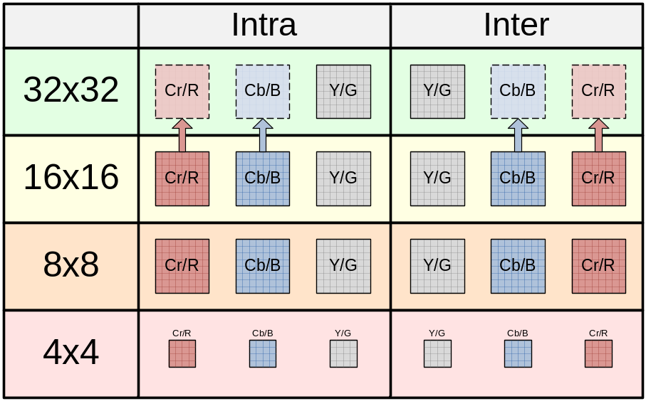
Figure 4-23 – Scaling lists

Scaling lists for transform skipped TUs
Scaling lists are not used for any transform-skipped TUs, other than 4×4.

Transform selection for the 4:2:2 chroma format
When the 4:2:2 chroma format is in use, a TU has a rectangular chroma block. In this case, the rectangular chroma blocks are divided into two square TBs per channel and existing square transforms are used for the TBs. A separate coded block flag is signalled for each TB. Intra prediction reconstruction occurs separately for the two square blocks within a rectangular chroma block, enabling the lower block to be predicted from the reconstructed upper block. Deblocking of these new boundaries is described in Section 4.13.
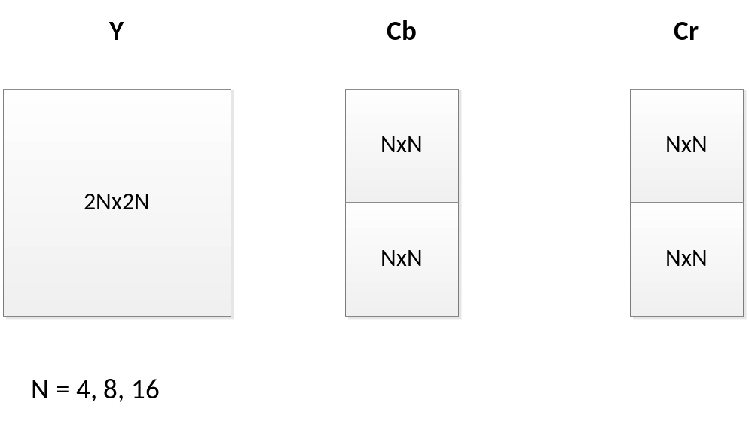
Figure 4-24 – Square transform arrangement for the 4:2:2 chroma format.

Chroma QP initialization offset table
When the chroma format is set to 4:2:2 or 4:4:4, the chroma QPc is initialized according to the luma qPi using the formula Min( qPi, 51 ). In particular, the mapping relationship of Table 8-10 of [2] is not used.

Extended precision processing
An extended_precision_processing_flag (as configured by ExtendedPrecision) is provided to allow increased internal precision, particularly for use at higher bit depths. When this flag is set to one, the internal width of the transform and the entropy coder (g_maxTrDynamicRange[channel]in the software model) are increased according to the selected bit depth. Figure 4-24 shows the bit depths in the HEVC encoding path.

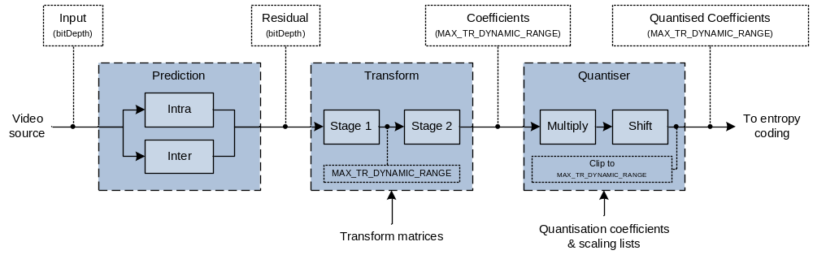
Figure 4-25 – Diagram showing magnitude bit depths in HEVC encoding path
Table 4-6 shows the relationship between the internal precisions and the bit depth.
Table 44-6 – g_maxTrDynamicRange[channel]
extended_precision_processing_flag | Bit depth[channel]
extended_precision_processing_flag | 16 | 15 | 14 | 13 | 12 | 11 | 10 | 9 | 8
1 | 22 | 21 | 20 | 19 | 18 | 17 | 16 | 15
0 | 15

CU-adaptive chroma QP offset
A chroma QP offset adjustment may be signalled at the CU level, for CUs down to a particular depth (signalled via diff_cu_chroma_qp_adjustment_depth). The same QP offset may also be applied to subsequent sibling or child CUs within the CTU tree if the maximum depth is reached. This is similar in principle to the operation of delta QP signalling in the current HEVC specification. To provide additional flexibility in terms of number of offsets, each CU that invokes the mode may signal an index into an offset table. This offset table contains up to five pairs of chroma QP offset values (cb_qp_adjustment, cr_qp_adjustment). The offset table is signalled in the PPS, limiting the rate cost of providing the chroma QP offsets. If the table contains one offset then no index is signalled. The chroma QP adjustment values are restricted such that the total deviation from the luma QP is limited to ±12.
For a CU where the offset is applied, each chroma QP adjustment value in a pair is applied to the corresponding chroma component. The feature is globally enabled through use of a picture parameter set flag chroma_qp_adjustment_enabled_flag, and locally through a slice header flag slice_chroma_qp_adjustment_enabled_flag.

Slice QP offset
The configuration option dQPFile allows specification of a QP offset to be applied to all slices belonging to a picture. When this option is specified with a valid file name, the encoder reads a text file with as many lines as the pictures to be encoded and stores these values in the array m_aidQP in class TAppEncCfg where the i-th entry in this array contains the QP offset applied to all slice belonging to the picture with picture order count equal to i.

Residual prediction in case of transquant bypass and transform skip
When lossless coding is used (i.e. cu_transquant_bypass_flag is equal to one) and implicit_rdpcm_enabled_flag is equal to one, the residues obtained from intra prediction are further predicted using DPCM. Residual DPCM is only applied when the intra prediction direction is either horizontal or vertical. For residues obtained from inter prediction, RDPCM is applied if explicit_rdpcm_enabled_flag is equal to one. In this case the encoder selects whether to apply RDPCM on the residues and if it is applied, whether to perform RDPCM along the horizontal or vertical direction. This decision is based on the sum of absolute difference (SAD) computed over the residues. The decision which minimises the SAD is selected as the best and signalled to the decoder using two binary flags: one to signal whether RDPCM is applied and one to signal the direction in which RDPCM is applied.
When lossy coding is used (i.e. cu_transquant_bypass_flag is equal to zero), RDPCM may be applied at TU level and only for those TUs which are transform skipped (e.g. 4×4 transform units). For intra TUs, RDPCM is always applied when implicit_rdpcm_enabled flag is equal to one for intra coded transform-skip TUs with horizontal or vertical intra prediction mode, so there is no additional signalling. For inter TUs, when explicit_rdpcm_enabled_flag is equal to one, the same mechanism used for lossless coding is followed. For intra and inter coding, RDPCM is computed using the reconstructed residues (i.e. after inverse quantization) in order to avoid any drift between the encoder and the decoder. In particular the process can be formalized as follows. Let 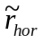 and 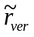 be the residues obtained by the RDPCM application. Let 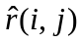 be the residue obtained after inverse quantization and r(i, j) the original residue (i.e. obtained by either intra or inter prediction). Over an N×N block, the residues and are therefore defined as follows:
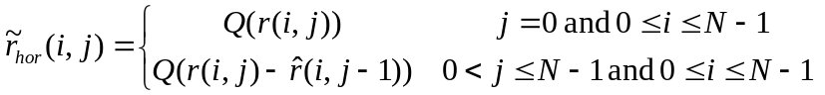
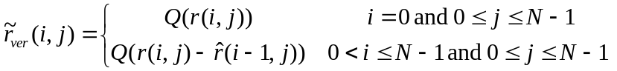,
where Q denotes the forward quantization operation.
The implicit_rdpcm_enabled_flag and explicit_rdpcm_enabled_flag are controlled using the configuration options ImplicitResidualDPCM and ExplicitResidualDPCM respectively.

Entropy coding
HEVC uses context adaptive binary arithmetic coding (CABAC) and variable length codes. Each syntax element is binarised using a combination of context coded bins and bypass bins. Context coded bins have an associated context, indicating the probable symbol value. The cost of coding a context coded bin depends on the probability and whether the symbol to be coded is equal to the likely symbol value. Bypass coded bins have no associated context and have an equal cost for coding each of a 0 or 1 symbol. Context coding allows adaptation to the probability distribution of symbol values for a given bin. Further adaptation is provided by context selection. A given context coded bin may use one of several contexts, the context being selected based on information previously included in the bitstream.
Variable length codes are used above the slice layer and in the slice header.

CABAC alignment
When cabac_bypass_alignment_enabled_flag is equal to one (as configured by AlignCABACBeforeBypass), the CABAC engine is bit-aligned (i.e. range is set to 256) prior to the coding of sign bits if there are any coefficients that require coeff_abs_level_remaining syntax elements. Note that once the CABAC engine is bit-aligned, it will remain bit-aligned until a context coded bin is encountered. Alignment prior to decoding equi-probable CABAC bins allows those bins to be read directly from the bit-stream.
Bit alignment results in bypass bins being aligned in the bitstream, i.e. a decoder can read a given bypass bin directly from the bitstream.

Coefficient Coding

Transform skip residual rotation
When transform_skip_rotation_enabled_flag is equal to one (as configured by ResidualRotation), the residual of a 4x4 transform-skipped block or transquant-bypass block is rotated by 180 degrees. Due to the symmetry of the scans used in HEVC, this is equivalent to reversing the scan orders.

Significance map context modelling
When transform_skip_context_enabled_flag is equal to one (as configured by SingleSignificanceMapContext), a separate single context is used for the sig_coeff_flag for TUs that are transform-skipped or transquant-bypassed

Rice parameter adaptation
When persistent_rice_adaptation_enabled_flag is equal to one (as configured by GolombRiceParameterAdaptation), an alternative mechanism for initializing the Rice parameter used for coding coeff_abs_level_remaining is available.
In this scheme, the 4×4 sub-blocks are divided into different categories (“sbType”). For each sub-block, the initial Rice parameter is derived based on previously coded sub-blocks in the same category. The categorization is based on whether the block is a transform-skip block (“isTSFlag”) or in trans-quant bypass (isTQBFlag) and whether it is the luma component
sbType = isLuma * 2 + (isTSFlag | | isTQBFlag)
Stats statCoeff are maintained for each sub-block type (sbType) depending on the absolute coefficient value (uiLevel):
if (uiLevel >= ( 3 << ( statCoeff[ sbType ] / 4 ) ) ) statCoeff[ sbType ] ++;
else if ( ( 2 * uiLevel ) < ( 1 << ( statCoeff[ sbType ] / 4 ) ) ) statCoeff[ sbType ] --;
This variable is updated at most once per 4×4 sub-block using the value of the first coded coeff_abs_level_remaining of the sub-block. The entries of statCoeff are reset to 0 at the beginning of the slice (like the CABAC context variables).
The value of statCoeff is used to initialize the Rice parameter at the beginning of each 4×4 sub-block as
cRiceParam = Min( maxRicePara, statCoeff/4 ).
When this mechanism for initialization is enabled, the maximum Rice parameter value is unrestricted (i.e. limited only by the maximum transform dynamic range).

Maximum coeff_abs_level_remaining codeword length restriction
When extended_precision_processing_flag is enabled, the maximum codeword length of the coeff_abs_level_remaining syntax element is limited to 32-bits. The maximum codeword length is achieved with the Rice parameter is equal to zero. The maximum codeword length is dependent on the dynamic range of transform and quantizer stages, referred to as ‘MAX_TR_DYNAMIC_RANGE’ in the HEVC Test Model 16.5 software. When extended_precision_processing_flag is enabled, MAX_TR_DYNAMIC_RANGE is set equal to the bit-depth plus six bits.
Binarization of coeff_abs_level_remaining is modified such that the maximum prefix length is given by:
maximumPrefixLength = 32 – (3 + MAX_TR_DYNAMIC_RANGE)
When this prefix length is reached, the corresponding suffix length is then given by:
suffixLength = MAX_TR_DYNAMIC_RANGE – rParam
This results in a maximum codeword length for coeff_abs_level_remaining of 32-bits.

Cross-component prediction
An adaptive cross-component residual prediction scheme (i.e., between colour channels) is provided, where a prediction is performed between the luma residual signal and the chroma residual signals. The chroma residual signal is predicted from the luma residual signal at the encoder side as:
(1)
and it is compensated at the decoder side as:
(2)
where 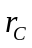 denotes the chroma residual sample at a position 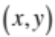, 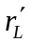 denotes the reconstructed residual sample of the luma component, 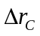 denotes the predicted signal using inter-colour prediction, 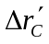denotes the reconstructed signal after coding and decoding , and 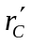 denotes the reconstructed chroma residual.
The variable α is chosen from 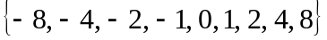. This set of values allows good utilization of the correlation between luma and chroma residual signals, including when they are negatively correlated. The absolute value of α, abs(α) is mapped to M(α) according to Table 4-7 before binarization. M(α) is binarized using truncated unary (TU) code and coded using CABAC, with a separate context for each bin in the TU code. If α is not zero, another bin is used to code the sign of α. At the decoder side, after CABAC decoding, M(α) is inversely mapped back to abs(α).
Table 44-7 – α Mapping Table.
abs(α) | M(α)
0 | 0
1 | 1
2 | 2
4 | 3
8 | 4

This prediction is performed both for intra- and inter-coded blocks. However, in case of intra-coded blocks, only those with DM chroma mode are allowed to use this prediction.
For each TU, if the coded block flag of the luma component is zero, α is not signaled and no prediction is performed. Otherwise, α is signalled separately for each chroma component.
When encoding RGB source material, the G component should be encoded as the luma component.
The use of cross-component prediction is signalled using cross_component_prediction_enabled flag and is configured using CrossComponentPrediction.
When reconstruction based cross-component prediction estimate is enabled, use the decoded residual rather than the pre-transform encoder-side residual for determining the alpha value. This is configured using ReconBasedCrossCPredictionEstimate.
If the luma bit-depth differs from the chroma bit-depth, for cross component prediction the luma residual is scaled to align with the chroma bit-depth by either a right-shift or a left-shift operation.

Loop Filtering

Overview of Loop filtering
HEVC includes two processing stages in the in-loop filter: a deblocking filter and then a sample adaptive offset (SAO) filter. The deblocking filter aims to reduce the visibility of blocking artefacts and is applied only to samples located at block boundaries. The SAO filter aims to improve the accuracy of the reconstruction of the original signal amplitudes and is applied adaptively to all samples, by conditionally adding an offset value to each sample based on values in look-up tables defined by the encoder.

Deblocking filter
A deblocking filter process is performed for each CU in the same order as the decoding process. First vertical edges are filtered (horizontal filtering) then horizontal edges are filtered (vertical filtering). Filtering is applied to 8×8 block boundaries which are determined to be filtered, both for luma and chroma components. 4×4 block boundaries are not processed in order to reduce the complexity.
Figure 4-26 illustrates the overall flow of deblocking filter processes. A boundary can have three filtering status values: no filtering, weak filtering and strong filtering. Each filtering decision is based on boundary strength, Bs, and threshold values, β and t_{C}.

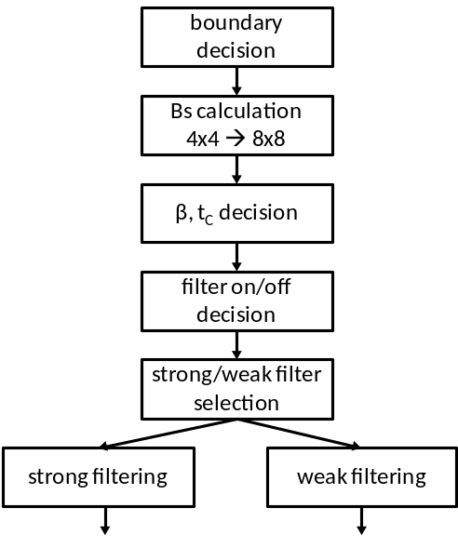
Figure 4-27 – Overall processing flow of deblocking filter process

Boundary decision
Two kinds of boundaries are involved in the deblocking filter process: TU boundaries and PU boundaries. CU boundaries are also considered, since CU boundaries are necessarily also TU and PU boundaries. When PU shape is 2NxN (N > 4) and RQT depth is equal to 1, TU boundaries at 8x8 block grid and PU boundaries between each PU inside the CU are also involved in the filtering.

Boundary strength calculation
The boundary strength (Bs) reflects how strong a filtering process may be needed for the boundary. A value of 2 for Bs indicates strong filtering, 1 indicates weak filtering and 0 indicates no deblocking filtering.,
Let P and Q be defined as blocks which are involved in the filtering, where P represents the block located to the left (vertical edge case) or above (horizontal edge case) the boundary and Q represents the block located to the right (vertical edge case) or above (horizontal edge case) the boundary. Figure 4-27 illustrates how the Bs value is calculated based on the intra coding mode, the existence of non-zero transform coefficients, reference picture, number of motion vectors and motion vector difference.
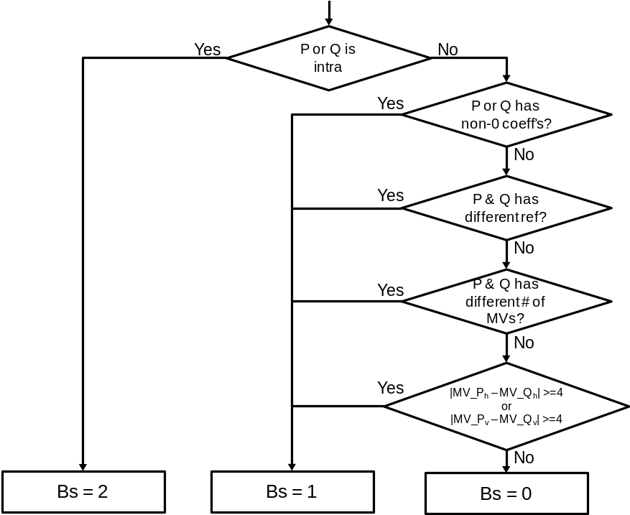
Figure 4-28 – Flow diagram for Bs calculation
Bs is calculated on a 4×4 block basis, but it is re-mapped to an 8×8 grid. The maximum of the two values of Bs which correspond to 8 pixels consisting of a line in the 4×4 grid is selected as the Bs for boundaries in the 8×8 grid.
At the CTU boundary, information on every second block (on a 4×4 grid) to the left or above is re-used as depicted in Figure 4-28, in order to reduce line buffer memory requirement.
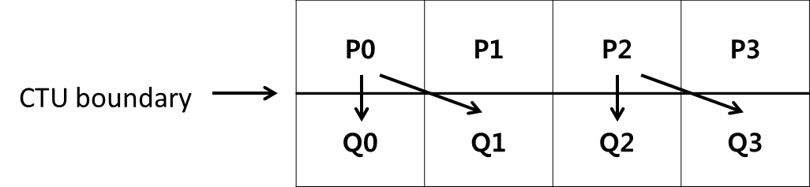
Figure 4-29 – Referred information for Bs calculation at CTU boundary

Threshold variables
Threshold values β′ and t_{C}′ are involved in the filter on/off decision, strong and weak filter selection and weak filtering process. These are derived from the value of the luma quantization parameter Q as shown in Table 4-8 .
Table 44-8 – Derivation of threshold variables from input Q
Q | 0 | 1 | 2 | 3 | 4 | 5 | 6 | 7 | 8 | 9 | 10 | 11 | 12 | 13 | 14 | 15 | 16 | 17 | 18
β′ | 0 | 0 | 0 | 0 | 0 | 0 | 0 | 0 | 0 | 0 | 0 | 0 | 0 | 0 | 0 | 0 | 6 | 7 | 8
t_{C}′ | 0 | 0 | 0 | 0 | 0 | 0 | 0 | 0 | 0 | 0 | 0 | 0 | 0 | 0 | 0 | 0 | 0 | 0 | 1
Q | 19 | 20 | 21 | 22 | 23 | 24 | 25 | 26 | 27 | 28 | 29 | 30 | 31 | 32 | 33 | 34 | 35 | 36 | 37
β′ | 9 | 10 | 11 | 12 | 13 | 14 | 15 | 16 | 17 | 18 | 20 | 22 | 24 | 26 | 28 | 30 | 32 | 34 | 36
t_{C}′ | 1 | 1 | 1 | 1 | 1 | 1 | 1 | 1 | 2 | 2 | 2 | 2 | 3 | 3 | 3 | 3 | 4 | 4 | 4
Q | 38 | 39 | 40 | 41 | 42 | 43 | 44 | 45 | 46 | 47 | 48 | 49 | 50 | 51 | 52 | 53
β′ | 38 | 40 | 42 | 44 | 46 | 48 | 50 | 52 | 54 | 56 | 58 | 60 | 62 | 64 | - | -
t_{C}′ | 5 | 5 | 6 | 6 | 7 | 8 | 9 | 10 | 11 | 13 | 14 | 16 | 18 | 20 | 22 | 24
The variable β is derived from β′ as follows:
β = β′ * ( 1 << ( BitDepth_{Y} − 8 ) )
The variable t_{C} is derived from t_{C}′ as follows:
t_{C} = t_{C}′ * ( 1 << ( BitDepth_{Y} − 8 ) )

Filter on/off decision for 4 lines
The filter on/off decision is made using 4 lines grouped as a unit, to reduce computational complexity. Figure 4-29 illustrates the pixels involving in the decision. The 6 pixels in the two red boxes in the first 4 lines are used to determine whether the filter is on or off for those 4 lines. The 6 pixels in the two red boxes in the second group of 4 lines are used to determine whether the filter is on or off for the second group of 4 lines.
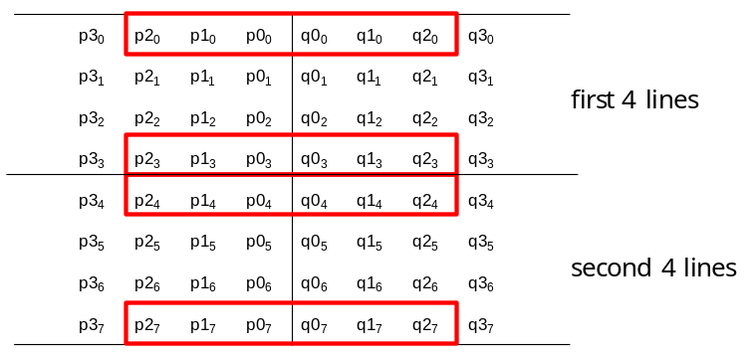
Figure 4-30 – Pixels involved in filter on/off decision and strong/weak filter selection
The following variables are defined:
dp0 = | p_{2,0} – 2*p_{1,0} + p_{0,0} |
dp3 = | p_{2,3} – 2*p_{1,3} + p_{0,3} |
dq0 = | q_{2,0} – 2*q_{1,0} + q_{0,0} |
dq3 = | q_{2,3} – 2*q_{1,3} + q_{0,3} |
If dp0+dq0+dp3+dq3 < β, filtering for the first four lines is turned on and the strong/weak filter selection process is applied. If this condition is not met, no filtering is done for the first 4 lines.
Additionally, if the condition is met, the variables dE, dEp1 and dEp2 are set as follows:
dE is set equal to 1
If dp0 + dp3 < (β + ( β >> 1 )) >> 3, the variable dEp1 is set equal to 1
If dq0 + dq3 < (β + ( β >> 1 )) >> 3, the variable dEq1 is set equal to 1
A filter on/off decision is made in a similar manner as described above for the second group of 4 lines.

Strong/weak filter selection for 4 lines
If filtering is turned on, a decision is made between strong and weak filtering. The pixels involved are the same as those used for the filter on/off decision, as depicted in Figure 4-29. If the following two sets of conditions are met, a strong filter is used for filtering of the first 4 lines. Otherwise, a weak filter is used.
1) 2*(dp0+dq0) < ( β >> 2 ), | p3₀ – p0₀ | + | q0₀ – q3₀ | < ( β >> 3 ) and | p0₀ – q0₀ | < ( 5* t_{C} + 1 ) >> 1
2) 2*(dp3+dq3) < ( β >> 2 ), | p3₃ – p0₃ | + | q0₃ – q3₃ | < ( β >> 3 ) and | p0₃ – q0₃ | < ( 5* t_{C} + 1 ) >> 1
The decision on whether to select strong or weak filtering for the second group of 4 lines is made in a similar manner.

Strong filtering
For strong filtering, the filtered pixel values are obtained by the following equations. Note that three pixels are modified using four pixels as an input for each P and Q block, respectively.
p₀’ = ( p₂ + 2*p₁ + 2*p₀ + 2*q₀ + q₁ + 4 ) >> 3
q₀’ = ( p₁ + 2*p₀ + 2*q₀ + 2*q₁ + q₂ + 4 ) >> 3
p₁’ = ( p₂ + p₁ + p₀ + q₀ + 2 ) >> 2
q₁’ = ( p₀ + q₀ + q₁ + q₂ + 2 ) >> 2
p₂’ = ( 2*p₃ + 3*p₂ + p₁ + p₀ + q₀ + 4 ) >> 3
q₂’ = ( p₀ + q₀ + q₁ + 3*q₂ + 2*q₃ + 4 ) >> 3

Weak filtering
Δ is defined as follows.
Δ = ( 9 * ( q₀ – p₀ ) – 3 * ( q₁ – p₁ ) + 8 ) >> 4
When abs(Δ) is less than t_{C} *10,
Δ = Clip3( - t_{C} , t_{C} , Δ )
p₀’ = Clip1_{Y}( p₀ + Δ )
q₀’ = Clip1_{Y}( q₀ - Δ )
If dEp1 is equal to 1,
Δp = Clip3( -( t_{C} >> 1), t_{C} >> 1, ( ( ( p₂ + p₀ + 1 ) >> 1 ) – p₁ + Δ ) >>1 )
p₁’ = Clip1_{Y}( p₁ + Δp )
If dEq1 is equal to 1,
Δq = Clip3( -( t_{C} >> 1), t_{C} >> 1, ( ( ( q₂ + q₀ + 1 ) >> 1 ) – q₁ – Δ ) >>1 )
q₁’ = Clip1_{Y}( q₁ + Δq )
Note that a maximum of two pixels are modified using three pixels as an input for each P and Q block, respectively.

Chroma filtering
The boundary strength Bs for chroma filtering is inherited from luma. If Bs > 1, chroma filtering is performed. No filter selection process is performed for chroma, since only one filter can be applied. The filtered sample values p₀’ and q₀’ are derived as follows.
Δ = Clip3( -t_{C}, t_{C}, ( ( ( ( q₀ – p₀ ) << 2 ) + p₁ – q₁ + 4 ) >> 3 ) )
p₀’ = Clip1_{C}( p₀ + Δ )
q₀’ = Clip1_{C}( q₀ - Δ )
When the 4:2:2 chroma format is in use, each chroma block has a rectangular shape and is coded using up to two square transforms. This process introduces additional boundaries between the transform blocks in chroma. These boundaries are not deblocked (blue dotted lines in Figure 4-30.)
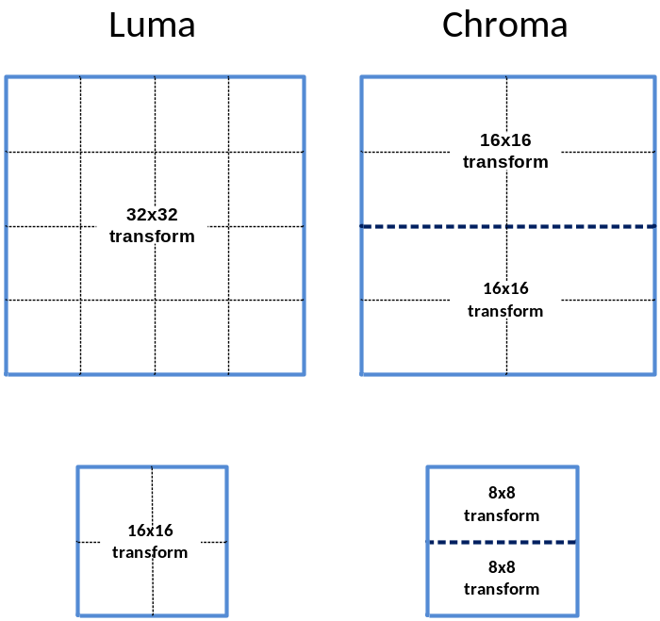
Figure 4-31 – Deblocking behaviour in the 4:2:2 chroma format.

Sample adaptive offset filter
Sample adaptive offset (SAO) is applied to the reconstructed signal after the deblocking filter by using offsets specified for each CTB by the encoder. The HM encoder first makes the decision on whether or not the SAO process is to be applied for current slice. If SAO is applied for the slice, each CTB is classified as one of five SAO types as shown in Table 4-9. The concept of SAO is to classify pixels into categories and reduces the distortion by adding an offset to pixels of each category. SAO operation includes edge offset (EO) which uses edge properties for pixel classification in SAO type 1-4 and band offset (BO) which uses pixel intensity for pixel classification in SAO type 5. Each applicable CTB has SAO parameters including sao_merge_left_flag, sao_merge_up_flag, SAO type and four offsets. If sao_merge_left_flag is equal to 1, the current CTB will reuse the SAO type and offsets of the CTB to the left. If sao_merge_up_flag is equal to 1, the current CTB will reuse SAO type and offsets of the CTB above.
Table 44-9 – Specification of SAO type
SAO type | sample adaptive offset type to be used | Number of categories
0 | None | 0
1 | 1-D 0-degree pattern edge offset | 4
2 | 1-D 90-degree pattern edge offset | 4
3 | 1-D 135-degree pattern edge offset | 4
4 | 1-D 45-degree pattern edge offset | 4
5 | band offset | 4

Operation of each SAO type
Edge offset uses four 1-D 3-pixel patterns for classification of the current pixel p by consideration of edge directional information, as shown in Figure 4-31. From left to right these are: 0-degree, 90-degree, 135-degree and 45-degree.

 | p |  |  |  | p |  |  |  | p |  |  |  | p
Figure 4-32 – Four 1-D 3-pixel patterns for the pixel classification in EO

Each CTB is classified into one of five categories according to Table 3-9.
Table 44-10 – Pixel classification rule for EO
Category | Condition | Meaning
0 | None of the below | Largely monotonic
1 | p < 2 neighbours | Local minimum
2 | p < 1 neighbour && p == 1 neighbour | Edge
3 | p > 1 neighbour && p == 1 neighbour | Edge
4 | p > 2 neighbours | Local maximum

Band offset (BO) classifies all pixels in one CTB region into 32 uniform bands by using the five most significant bits of the pixel value as the band index. In other words, the pixel intensity range is divided into 32 equal segments from zero to the maximum intensity value (e.g. 255 for 8-bit pixels). Four adjacent bands are grouped together and each group is indicated by its most left-hand position as shown in Figure 4-32. The encoder searches all position to get the group with the maximum distortion reduction by compensating offset of each band.
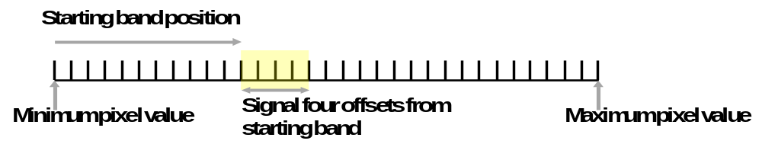
Figure 4-33 – Four bands are grouped together and represented by its starting band position

Format range extensions options for SAO
Shift values for luma and chroma for the offset value are included in the PPS. There is no change to classification and the shift values are in the range of 0 to Max(BitDepth – 10, 0). The shift values for luma and chroma are configured in the encoder using SaoLumaOffsetBitShift and SaoChromaOffsetBitShift, respectively.

Wavefront parallel processing
Wavefront parallel processing (WPP) produces a bitstream that can be processed using one or more cores running in parallel. When WPP is used, a slice is divided into rows of CTUs (per tile). The first row is processed in an ordinary way, the second row can begin to be processed after only two CTUs have been processed in the first row, the third row can begin to be processed after only two CTUs have been processed in the second row, and so on. The context models of the entropy coder in each row are inferred from those in the preceding row with a two-CTU processing lag. WPP provides a form of processing parallelism within a slice, without the loss of compression performance that might be expected by using tiles within a slice.
The following operations are performed by the HM encoder.
- When starting the encoding of the first CTU in a CTU row, the following process is applied:
- if the last CU of the second CTU of the row above is available, the CABAC probabilities are set to the values stored in the buffer.
- if not, the CABAC probabilities are reset to the default values
- When the encoding of the second CTU in a CTU row is finished, the CABAC probabilities are stored in a buffer
- If the encoding of the last CTU in a CTU row is finished and the end of a slice has not been reached, CABAC is flushed and a byte alignment is performed.
Entry point offsets are written in the slice header. Each CTU row in the slice has an entry point offset, in byte units, that indicates where the corresponding data starts in the slice data. When WPP is used, a slice that does not start at the beginning of a CTU row does not finish after the last CTU in the same row. When a slice starts at the beginning of a CTB row, there is no constraint on where it finishes.
In all but the high throughput RExt profiles, WPP and tiles cannot be used simultaneously.
WPP is enabled in the HM Encoder by setting WaveFrontSynchro to 1.

Profiles, Levels and Tiers
The HEVC test model 16 uses particular tools in accordance with the specified profile. To enable the use of tools available in format range extensions profiles, the Profile encoder option is set to the value main-RExt or high-RExt.
For the main or main10 profiles, set the Profile encoder option to the value main or main10, respectively.
Further control of the profile of the format range extensions profiles is provided as shown in Table 6-1.
Table 56-1 – Bitstream indications for format range extensions profiles.
Configuration option | Description
IntraConstraintFlag | When the encoder is configured with IntraConstraintFlag, the general_intra_constraint_flag is set accordingly.  If this flag is set to 1, only intra slices may be used.
LowerBitRateConstraintFlag | When the encoder is configured with LowerBitRateConstraintFlag, the general_lower_bit_rate_constraint_flag is set accordingly.  Note that LowerBitRateConstraintFlag cannot be false if IntraConstraintFlag is false.
MaxBitDepthConstraint | Specifies the maximum allowed luma and chroma internal bit-depths.  If no value (or 0) is specified, the MaxBitDepthConstraint is assumed to be the internal bit depth. The value of MaxBitDepthConstraint controls the setting of the following syntax elements:  - general_max_12bit_constraint_flag  - general_max_10bit_constraint_flag  - general_max_8bit_constraint_flag
MaxChromaFormatConstraint | Specifies the maximum allowed chroma format.  If no value (or 0) is specified, the MaxChromaFormatConstraint is assumed to be that of the internal chroma format. The value of MaxChromaFormatConstraint controls the setting of the following syntax elements:  - general_max_422chroma_constraint_flag  - general_max_420chroma_constraint_flag  - general_max_monochrome_constraint_flag

The following syntax elements specify the profile being used:
- general_max_12bit_constraint_flag
- general_max_10bit_constraint_flag
- general_max_8bit_constraint_flag
- general_max_422chroma_constraint_flag
- general_max_420chroma_constraint_flag
- general_max_monochrome_constraint_flag
- general_intra_constraint_flag
- general_one_picture_only_constraint_flag (HM always writes a ‘0’ for this flag)
- general_lower_bit_rate_constraint_flag
- general_profile_idc (set to 4 for all profiles currently specified for the format range extensions profiles).
The encoder does not currently verify that the combination of constraints flags describe a format range extensions profile. However, it is likely that automatic generation of the constraint flags will follow the rules defined in Table 6-2.

Table 56-2 – Mapping between user configuration and automatically calculated bitstream format range extensions profile indication.
Mode | Chroma format | General RExt tools | Extended precision | Chroma QP tool | Maximum bit depth of all components
 |  |  |  |  | 8 | 9, 10 |  | 11, 12 |  | 13, 14, 15, 16
Intra | 4:0:0 | None | Off | n/a | Main Intra | Main 10 Intra |  | Main 12 Intra |  | Main 4:4:4 16 Intra
Intra | 4:2:0 | None | Off | Off
 |  |  |  | On | Main 4:2:2 10 Intra |  |  | Main 4:2:2 12 Intra |  | Main 4:4:4 16 Intra
Intra | 4:2:2 | None | Off | - |  |  |  |  |  | Main 4:4:4 16 Intra
Intra | 4:4:4 | None | Off | - | Main 4:4:4 Intra | Main 4:4:4 10 Intra |  | Main 4:4:4 12 Intra |  | Main 4:4:4 16 Intra
Intra | - | Some/All | Off | -
Intra | - | - | On | - |  |  |  |  |  | Main 4:4:4 16 Intra
Inter | 4:0:0 | None | Off | n/a | Monochrome 12 |  |  |  |  | Monochrome 16
Inter | 4:0:0 | - | On | n/a |  |  |  |  |  | Monochrome 16
Inter | 4:0:0 | Some/All | Off | n/a |  |  |  |  |  | Monochrome 16
Inter | 4:2:0 | None | Off | Off | Main 12
Inter | 4:2:0 | - | On | -
Inter | 4:2:0 | Some/All | Off | - | Main 4:4:4 | Main 4:4:4 10 |  | Main 4:4:4 12
Inter | 4:2:0 | None | Off | On | Main 4:2:2 10 |  |  | Main 4:2:2 12
Inter | 4:2:2 | None | Off | - |  |  |  |  |  | n/a
Inter | 4:2:2 | - | On | - |  |  |  |  |  | n/a
Inter | 4:2:2 | Some/All | Off | - | Main 4:4:4 | Main 4:4:4 10 |  | Main 4:4:4 12 |  | n/a
Inter | 4:4:4 | - | Off | - | Main 4:4:4
Inter | 4:4:4 | - | On | -

Description of HM Encoder and encoding methods
This section describes the work flow of HM to select parameters such as coding mode, QP, SAO offsets, etc. The section starts by describing some global settings and methods such as encoder configurations, coding mode selection for inter prediction, picture partitioning associated with tiles and rate control. The focus will then move to describe the different cost functions used by the encoder in different processing stages (e.g. motion estimation). Finally, a description on the work flow at slice, CU, PU and TU level will conclude the section.

Encoder configurations

Overview of encoder configurations
The HM encoder is supplied alongside three key prediction structures, as used in the common test conditions [4] and [5]. These prediction structures are: intra-only, low-delay and random access. The reference picture list management depends on the temporal configuration.

Intra-only configuration
For intra-only coding, each picture in the source material is encoded as an IDR picture. No temporal reference pictures are used. One QP value is specified in the configuration file for all slice even though this value can vary throughout the sequence because rate control and/or other perceptual optimisations are applied. Figure 7-1 gives graphical presentation of an intra-only configuration, where the number associated with each picture represents the encoding order.
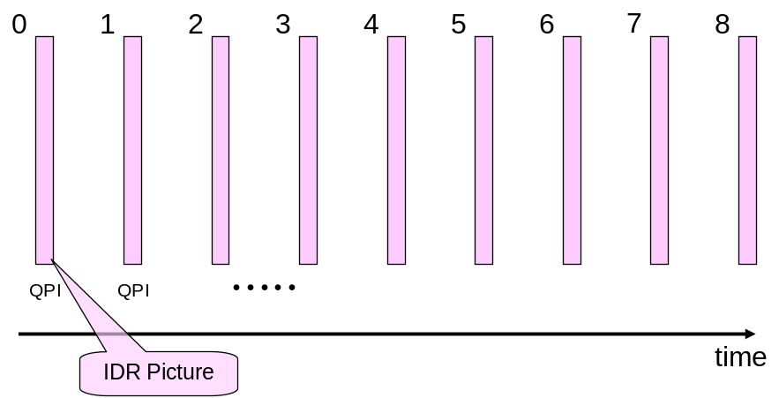
Figure 7-1 – Graphical presentation of intra-only configuration

Low-delay configurations
Two coding configurations have been defined for testing low-delay coding performance, referred to as ‘low-delay P’ and ‘low-delay B’. For low-delay coding conditions, only the first picture in a video sequence is encoded as an IDR picture. Subsequent pictures are each encoded using a P-slice for low-delay P mode or a B-slice for low-delay B mode. For both modes, the P or B slices only reference pictures preceding the current picture in display order. For low-delay B mode, both reference lists RefPicList0 and RefPicList1 are identical.
Figure 7-2 shows a graphical presentation of this low-delay. The number associated with each picture represents the encoding order. The QP of each inter coded picture is derived by adding an offset to the QP of the intra coded picture (QPI) depending on the temporal layer.
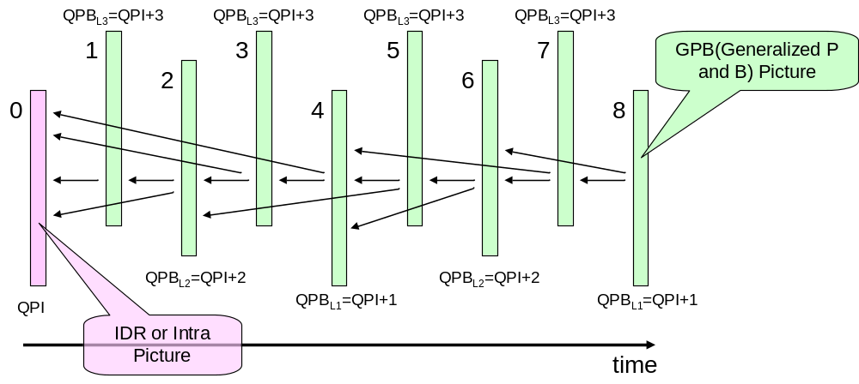
Figure 7-2 – Graphical presentation of low-delay configuration

Random-access configuration
For the random-access test condition, a hierarchical B structure is used for encoding. Figure 7-3 shows a graphical representation of a random-access configuration, where the number associated with each picture represents the encoding order. An intra-picture is encoded at approximately one second intervals in accordance with the IntraPeriod configuration option, configured based on the frame rate of the source material. The first intra-picture of a video sequence is encoded as an IDR picture and the other intra pictures are encoded as non-IDR intra pictures (“Open GOP”). The pictures located between successive intra pictures in display order are encoded as B-pictures. The inter-predicted picture (referred to as a ‘Generalised P and B picture) in Figure 7-3 below) is used as the lowest temporal layer that can refer to intra- or inter-pictures for inter prediction. The second and third temporal layers consist of referenced B pictures, while the highest temporal layer contains non-referenced B picture only. The QP of each inter-coded picture is derived by adding an offset to the QP of the intra-coded picture depending on the temporal layer. The reference picture list combination is used for management and entropy coding of the reference picture index.
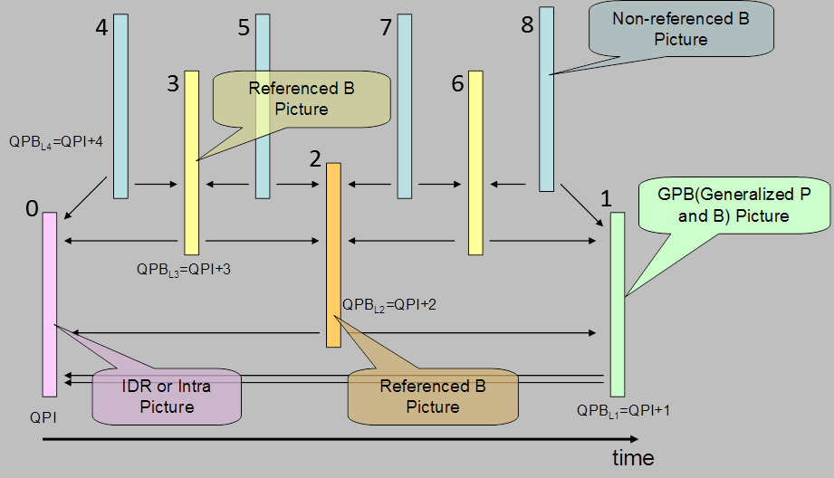
Figure 7-3 – Graphical presentation of random-access configuration

Cost mode
The cost function minimised by the encoder to select the best coding mode for each image area can be configured using the option CostMode. This can take one of the following four strings:
- lossy – this is the standard cost equation, where cost = distortion + (bits * lambda).
- sequence_level_lossless – this applies a cost in terms of bits and not distortion, where cost = (distortion / lambda) + bits. Although the cost is mathematically equivalent to the evaluation of the “lossy” cost, this is useful to ensure that when there is no distortion the cost is simply a function of bits, with no rounding errors caused by the use of lambda.
- lossless – this is equivalent to sequence_level_lossless, but also sets QP to the value of LOSSLESS_AND_MIXED_LOSSLESS_RD_COST_TEST_QP (by default 0) (since the QP is used during the encoder search for testing intra modes). This may be deprecated in future versions in favour of the user setting the QP manually.
- mixed_lossless_lossy – this uses the same cost equation as sequence level lossless, but also uses a lambda evaluated at the value of the macro LOSSLESS_AND_MIXED_LOSSLESS_RD_COST_TEST_QP_PRIME (by default 4) to derive lambdas so that lossless coded blocks are not affected by QP during their encoder search. This affects the intra search during fast evaluation of intra directions and inter search during evaluation of motion vector cost.

Inter-prediction search
The inter-prediction search function includes two modes of operation, a ‘multi-loop’ search and a ‘single component loop inter search’ mode. The single component loop inter search is enabled using the option SingleComponentLoopInterSearch
The multi-loop search function includes three loops over the colour channels, as follows:
- In the first component loop, the entropy coder is reset, blocks are transformed and quantized, then the entropy coding cost for the block is estimated.
- In the second component loop, the entropy coder is reset, and if the absolute sum of the quantized coefficients is non-zero, the block is dequantized and inverse-transformed and a cost is derived using the result of the first loop. Also, a cost is derived for the case where all residual coefficients are zero. The costs are compared and the lowest is selected. If the absolute sum of the quantized coefficients is zero, only the cost for this case is derived.
- In the third component loop, for each tested mode of transform skip and cross-component prediction the following occurs. Firstly, the entropy coder is restored and reset if the component is not Cr (i.e. cIdx < 2). Then the block is transform skipped and quantized, the block is then entropy code estimated and a cost is derived, and selected if it is an improvement upon the previous best cost.
After the three component loops, the entropy coder is restored and the decisions are encoded.
When the encoder is configured to use the single component loop inter search mode, the following occurs:
- A loop over each component occurs. For each tested mode of transform skip and (optionally) cross-component prediction, the following occurs. The entropy coder is restored and then reset. The block is then transformed and quantized. The entropy coding cost of the block is then estimated. If the absolute sum of the quantized coefficients is non-zero, the block is dequantized and inverse-transformed, otherwise the inverse-transformed block is set to all zeros. Then a cost is derived. If all optional tools are disabled, then a cost is derived for the tested mode for the case of all coefficients being zero. Then, the best cost is selected.
After the component loop, the entropy coder is reset and the decisions are encoded.

Rate control
The HM software implements a single pass rate control algorithm which provides a constant bit rate (CBR) mode. The algorithm is controlled using the RateControl configuration option and is based on a R-λ model as presented in document JCTVC-K0103 [6]. This model assumes an exponential relationship between the coding rate and the Lagrangian multiplier λ:
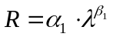
where α₁ and β₁ are constants dependent on the video source. The rate control process can be summarised into two main steps:
- Bit allocation,
- Quantization parameter derivation according to the used R-λ model.
Bit allocation is performed at the following levels of granularity: GOP, picture and CTU level. Initially, the rate controller computes the average bits per picture (R_{PicAvg}) from the target bitrate (R_{tar}) and the video frame rate (f):
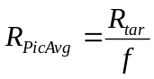
Then, bit allocation at the GOP level is performed using a smoothing window (SW) of 40 frame lengths and taking into account the number of pictures already coded (N_{coded}) and the bits spent on these pictures (R_{coded}). For the current GOP the target bits (T_{GOP}) are then given as:
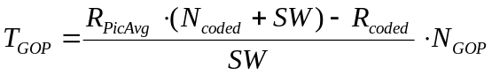
where N_{GOP} denotes the number of pictures in the current GOP. At the picture level bit allocation is performed taking into account T_{GOP} and the bits spent over the pictures inside the current GOP and already coded (CODED_{GOP}). The number of bits allocated for each picture also considers a weight. The weight models the relative number of bits that should be allocated to one picture with respect to the others. As an example, in the random access coding configuration, when a hierarchical GOP structure is used, pictures belonging to lower levels of the hierarchy will receive a larger number of bits since they will serve as reference for subsequent coded pictures (i.e. at higher levels of the hierarchy). Conversely those located to the higher level of the hierarchy will receive fewer bits. The weights used in HM are selected differently depending on whether random access or low delay GOP type is used. The target coding rate for current picture (T_{CurrPic}) is then given as:
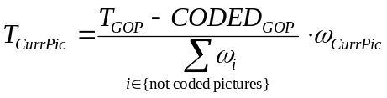
Finally, for each CTU the bit-rate is allocated taking into account the number of bits allocated for the picture of which the CTU belongs, the number of bits spent while encoding previous CTUs (CODED_{CTU}) and bits spent while coding high level syntax meta-data such as the slice header, SPS, PPS. As for picture bit allocation, CTUs are differently weighted depending on their complexity. The complexity metric measures the mean of absolute differences (MAD) between the original and the predictor used to encode the current CTU for inter-predicted pictures and the sum of absolute transform differences (SATD) for intra-predicted pictures. Therefore the target bits allocated for the current CTU (T_{CurrCTU}) is given by:
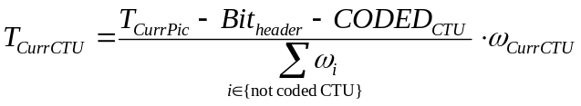
where Bit_{HEADER} denotes the bits spent while encoding high level syntax meta data and ω_{i} denotes the weighting factor for each CTU.
Once the available bits have been allocated for the current CTU, the quantization parameter QP can be obtained according to the used R-λ model. More precisely, the Lagrangian multiplier is derived from T_{CurrCTU} as follows:
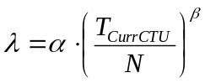
where N denotes the number of pixels contained in the current CTU. From λ, QP is finally obtained as:
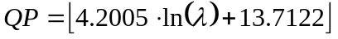
where the ⎣⋅⎦ operator returns the largest integer smaller than or equal to the argument and ln(·) is the natural logarithm. Parameters α and β are initialized to average values of (3.2003 and -1.367, respectively) and then updated by least square regression once a coded picture is available. Moreover, different values are used with respect to level of hierarchy of the GOP structure.
The HM rate control algorithm allows to manually set the initial QP value used for the first coded picture using option --InitialQP=value. If value is equal to zero the algorithm automatically derives the value using the R-λ model otherwise uses the value provided by the user. The remaining parameters associated to the rate control algorithm are listed in Table 6-3 along with a brief description.
Table 66-3. Configuration options for rate control algorithm.
Parameter name | Description
TargetBitrate | Target bitrate for the whole sequence measured in bit per second (bps)
KeepHierarchicalBit | Determines how bit allocation is done across different pictures. Allowed values are: 0 = uniform, 1 fixed ratio according to the used GOP structure (i.e. random access or low delay) and 2 = adaptive with respect to the source content
LCULevelRateControl | Switch between CTU-based or picture-based rate control
RCLCUSeparateModel | Selects whether to use α and β parameters on a CTU or picture basis
RCForceIntraQP | Force QP value for intra-pictures to be equal to the value specified with InitialQP

Coded picture buffer behaviour
When RCCpbSaturation is enabled, a ‘target bits saturation’ method is enabled that, in addition to meeting the target rate, also avoids CPB overflow and underflow.
To consider the coded picture buffer (CPB) of the hypothetical reference decoder (HRD), a rate control method should have three parameters (R, B, F) with a leaky bucket model. Figure 1 shows an example of CPB with the HRD parameters. R means the transmission bit rate, B is the CPB size, and F is the CPB fullness. In addition, this contribution denote that i is the frame number, b_{i} is the amount of bits for the i-th frame, and f means a frame rate. This contribution adds several parameters into the rate control algorithm of HM, because the rate control of HM without any considerations of CPB states cannot be used for practical applications under the conformance of the standard.

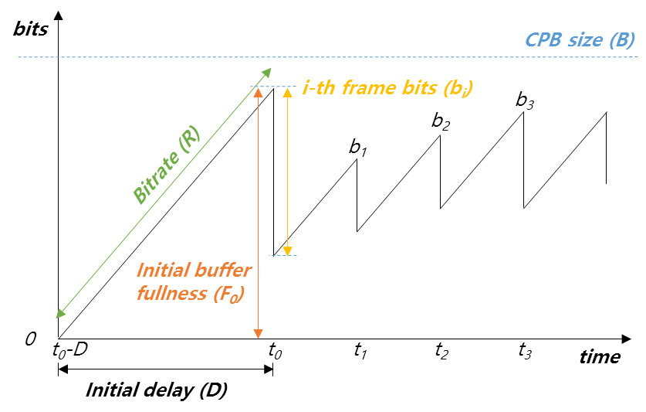
Figure 7-4 – CPB behaviour
Refer to [8] for more details.

Cost Functions
Various cost functions are used in the HM software encoder to determine costs used in making encoder decisions. This section documents the cost functions used in the encoding process of the HM software.6

Sum of Square Error (SSE)
The difference between two blocks with the same block size is produced using
Diff(i,j) = BlockA(i,j) - BlockB(i,j) (7-1)
SEE is computed using the following equation:
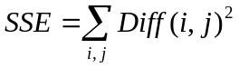 (7-2)

Sum of Absolute Difference (SAD)
SAD is computed using the following equation:
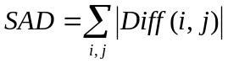 (7-3)

Hadamard transformed SAD (SATD)
Since the transformed coefficients are coded, an improved estimation of the cost of each mode can be obtained by estimating DCT with the Hadamard transform.
SATD is computed using:
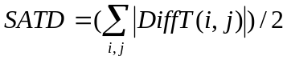 (7-4)
The Hadamard transform flag can be turned on or off. SA(T)D refers to either SAD or SATD depending on the status of the Hadamard transform flag.
SAD is used when computing full-pel motion estimation while SA(T)D is used for sub-pel motion estimation.

RD cost functions

Lagrangian constant values
In the HM encoder, lambda values that are used for cost computation are defined as
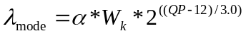 (7-5)
_{pred} 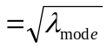 (7-6)
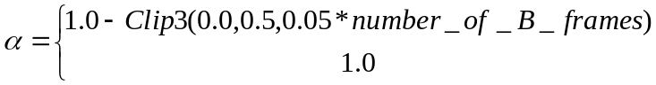 (7-7)
, for referenced pictures
, for non-referenced pictures
represents weighting factor dependent to encoding configuration and QP offset hierarchy level of current picture within a GOP, as specified in Table 7-1. Note that the value of derived from Table 7-1 is further modified by multiplying 0.95 when SATD based motion estimation is used.
Table 67-1 – Derivation of
K | QP offset hierarchy level | Slice type | Referenced
0 | 0 | I | - | 0.57
1 | 0 | P or B | 1 | RA: 0.442  LD: 0.578
2 | 1, 2 | P or B | 1 | RA: 0.3536 * Clip3( 2.0, 4.0, (QP-12)/6.0 )  LD: 0.4624 * Clip3( 2.0, 4.0, (QP-12)/6.0 )
4 | 3 | B | 0 | RA: 0.68 * Clip3( 2.0, 4.0, (QP-12)/6.0 )

Weighting factor for chroma component
The following weighting parameter w_{chroma} is used to derive lambda value 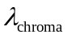to be used for chroma-specific decisions in RDOQ and SAO processes.
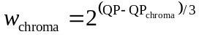 (7-8)
With this parameter, 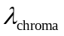is obtained by
 (7-9)
Note that the parameter w_{chroma} is also used to define the cost function used for mode decisions in order to weight the chroma part of SSE.

SAD based cost function for prediction parameter decision
The cost for prediction parameter decision J_{pred,SAD} is specified by the following formula.
J_{pred,SAD} =SAD + λ_{pred} * B_{pred}, (7-10)
where B_{pred} specifies bit cost to be considered for making decision, which depends on each decision case. λ_{pred} and SAD are defined in the section 7.1.4.1 and 7.1.2, respectively.

SATD based cost function for prediction parameter decision
The cost for motion parameter decision J_{pred,SATD} is specified by the following formula.
J_{pred,SATD} =SATD + λ_{pred} * B_{pred}, (7-11)
where B_{pred} specifies bit cost to be considered for making decision, which depends on each decision case. λ_{pred} and SATD are defined in the section 7.1.4.1 and 7.1.3, respectively.

Cost function for mode decision
The cost for mode decision J_{mode} is specified by the following formula.
J_{mode} =(SSE_{luma}+ w_{chroma} *SSE_{chroma})+ λ_{mode} * B_{mode,} (7-12)
where B_{mode} specifies bit cost to be considered for mode decision, which depends on each decision case. λ_{mode} and SSE are defined in the section 7.1.4.1 and 7.1.1, respectively.

Lambda modifiers
The HM encoder supports modifying lambda for performing mode decisions. Lambda can be modified independently for each temporal layer. A separate lambda modifier for intra slices can also be specified, also independently for each temporal layer.
Lambda modifiers are specified for each temporal layer using LambdaModifier0, LambdaModifier1, LambdaModifier2, LambdaModifier3, LambdaModifier4, LambdaModifier5, and LambdaModifier6. Lambda modifiers for intra pictures are specified providing LambdaModifierI with a comma separated list of lambda modifiers, specifying the lambda modifier for each temporal layer.

IQPFactor specifies the intra QP Factor for lambda computation. If negative, use the following formula:

0.57*(1.0 - Clip( 0.0, 0.5, 0.05*(isField ? (GOP_{size} - 1)/2 : GOP_{size} - 1) )) (7-13)

Slice and tile partitioning operation
The HM encoder can partition a picture into several slices and tiles. Slice and tile boundaries are aligned to CTU boundaries. The HM encoder has three ways of determining slice size: by specifying the maximum number of CTUs in a slice, by specifying the number of bytes in a slice, and by specifying the number of tiles in a slice. This mode is controlled by SliceMode, with SliceArgument used to control the maximum number of CTUs, bytes or tiles in a slice. Additionally, the controls for a slice segment are separate to those of a slice, with SliceSegmentMode and SliceSegmentArgument used. Separate controls allows bitstreams to contain a mixture of independent and dependent slice segments. Note that if the mode is set to limit the slice size by the maximum number of bytes per slice or by the maximum number of CTUs per slice, then a given slice will always terminate at the end of every tile and in addition, if a slice starts mid-way along a CTU row of a tile then it is terminated within the same row when wavefront parallel processing is enabled; similarly for slice segments.
Tiles are configured by the number of columns and rows (NumTileColumnsMinus1 and NumTileRowsMinus1 respectively), and are either specified as having a uniform spacing (TileUnformSpacing equal to 1), or the individual tile column widths (using TileColumnWidthArray) and tile row heights (using TileRowHeightArray) are used. Tiles do not need to be enabled: they are automatically enabled if more than one tile row or column is specified. The five encoder parameters correspond to syntax elements num_tile_colums_minus1, num_tile_rows_minus1, uniform_spacing_flag, col_width_minus1[i], and row_height_minus1[i].

Derivation process for slice-level coding parameters

Sample Adaptive Offset (SAO) parameters

Search the SAO type with minimum rate-distortion cost
In the HM encoder, the following process is performed to determine the SAO parameters for each CTB in the slice or tile:
- Loop over the three colour components in a CTB, performing the following steps:
  - Collect the statistical information for all SAO type as following
    - Set sao_type_idx = 0
    - Classified pixels into categories according to sao_type_idx.
      - Calculate the sum of differences between original signal and reconstructed signal in each category.
      - Calculate number of pixels in each category.
      - Calculate offsets using step 1.1.2.1 and step 1.1.2.2.
      - Calculate RD-cost
    - Set sao_type_idx = sao_type_idx+1; if sao_type_idx <= 5, run step 1.1.2; otherwise, end.
  - Determine the SAO parameters with lowest rate-distortion (RD) cost among the following three items.
    - If left CTB is available, calculate the RD cost by reusing the SAO parameters of left CTB.
    - If upper CTB is available, calculate the RD cost by reusing SAO parameters of upper CTB.
    - Five SAO types with minimum RD-cost in step 1.1.
  - Update pixels in DPB according to selected SAO type by adding offset.

Slice level on/off Control
A hierarchical coding of pictures is used for both low delay and random access configurations which allows the encoder to enable or disable SAO for picture with higher QP according to the percentage of CTBs to use SAO from the previous picture with lower QP. If previous picture with lower QP had more than 25% of CTBs using SAO type from 1-5, SAO will be enabled for the current picture, otherwise SAO will be disabled for the current picture.

Adaptive QP selection
When this tool is used, the quantization parameter (QP) for each slice is changed based on the distribution of quantized coefficients in previous pictures. More specifically, for the current slice, the QP used is given as the one which minimizes the following cost measure:
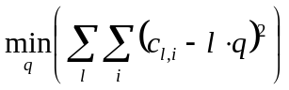
where q denotes the quantization step associated to QP and c_{l,i} denotes the i-th coefficient which is quantised to the level l. As stated above, the optimal QP derivation is computed using data from the previously coded picture to avoid two-pass encoding. The optimal quantization step q is then translated into the corresponding QP according to the mapping described in [1] and set as QP for the slice being encoded.

Adaptive search range for motion estimation
HM provides an adaptive search range (ASR) algorithm which varies the extent of the region used to search the best motion vector during motion estimation. The variation of the search range depends on the temporal distance between the current and the reference picture. This tool is enabled with the --ASR option and computes the new search range when the encoding of each slice starts.
More precisely, the search range for the current picture (SR_{curr}) is modified as follows:
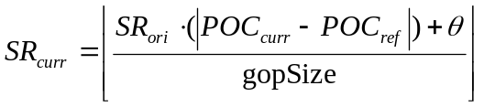,
where ⎣·⎦ denotes the floor operation, SR_{ori} denotes the original search range set from command line (64 in common test conditions [4], [5]), POC_{curr} and POC_{ref} are the picture order count for the current and reference picture, respectively, gopSize is the size of the group of picture and θ is a rounding offset equal to gopSize/2. The value of SR_{curr} is then clipped in the range [SR_{MIN}, SR_{ori}] where SR_{MIN} is the minimum search range specified by command line option MinSearchWindow (default value 8).

Derivation process for CU-level and PU-level coding parameters

Intra prediction mode and parameters
The encoder selects an intra prediction mode for a PU as follows:
- A candidate mode derivation step tests all possible prediction modes for the luma PB with an approximate prediction cost J_{pred,SATD} specified in the section 6.5.4.4. A pre-determined number of intermediate candidates are found for each PU size (8 for 4×4 and 8×8 PUs, 3 for other PU sizes). In this step, the number of coded bits for an intra prediction mode is set to B_{pred}.
- An RD optimization step, using the coding cost J_{mode} specified in the section 6.5.4.5, is applied to the previously determined candidate modes. During this step, prediction parameters and coefficients for luma component of the PU are accumulated into B_{mode}. Regarding the chroma PB mode decision, all possible intra chroma prediction modes are evaluated through RD decision process, where coded bits for intra chroma prediction mode and chroma coefficient are used as B_{mode}.

Rate-distortion penalty for intra coding
This tool is enabled with the configuration option RDpenalty and provides a fast mode decision for intra coding. Configuration option RDpenalty can take three values: 0 (i.e. disabled), 1 and 2. When the value is equal to one the encoder avoids splitting a transform unit when its size is smaller than 16 × 16 and its associated slice is not intra. When RDpenalty is set to 2, transform units with size 32 × 32 in non intra slices are not checked and the RQT search moves to the next level of recursion.

Inter prediction mode and parameters

Derivation of motion parameters
In the HM encoder, an inter-coded CU can be segmented into multiple inter-predicted PUs, each of which has a set of motion parameters consisting of one or more motion vectors (per RefPicListX), corresponding reference picture indices (ref_idx_lX) and prediction direction index (inter_pred_flag). Note that the current common test conditions those includes inter prediction coding are adopting reference picture list combination process, which is the case “X=c”. An inter-coded CU can be encoded with one of the following coding modes (“PredMode”): MODE_SKIP, MODE_INTER. For MODE_SKIP case, any sub-partitioning to smaller PUs is not allowed and its motion parameters are assigned to the CU itself, where the PU size is PART_2Nx2N. On the contrary, up to eight types of further partitioning to smaller PUs can be allowed for a CU coded with MODE_INTER. The PredMode and the CU partitioning shape (“PartMode”) are signaled by a CU level syntax element “part_type” as specified in Table 7-10 of the WD. For a MODE_INTER CU other than those having maximum depth, seven PU partitioning patterns (PART_2Nx2N, PART_2NxN, PART_Nx2N, PART_2NxnU, PART_2NxnD, PART_nLx2N and PART_nRx2N) can be selected. PART_NxN can only be chosen at maximum CU depth level but permission to set N to 4 is controlled by a specific flag in SPS (“inter_4x4_enabled_flag”). For each PU, PU-based Motion Merging (merge mode) or normal inter prediction with actually estimated motion parameters (inter mode) can be used. This section describes how luma motion parameters are obtained for each PU. It is noted that chroma motion vector are derived from luma motion vector of corresponding PU according to the normative process specified in section 8.4.2.1.10 of the WD, and the same reference picture index and prediction direction index as luma’s one are used in chroma components.

Motion Vector Prediction
For each PU, the best motion vector predictor is computed with the process specified as follows. Firstly, a set of motion vector predictor candidates for RefPicListX are derived with normative process specified in section 8.4.2.1.7 of the WD, by referring to motion parameters of neighbouring PUs. Then, the best one from the candidate set is determined by a criterion that selects a motion vector predictor candidate that minimizes the cost J_{pred,SAD} specified in the section 6.5.4.3, with setting the bits for an index specifying each motion vector predictor candidate to B_{pred}. The index corresponding to the selected best candidate is assigned to the mvp_idx_lX.

CU coding with MODE_SKIP
In the case of skip mode (i.e., PredMode == “MODE_SKIP”), motion parameters for the current CU(i.e., PART_2Nx2N PU) are derived by using merge mode. In this case, the motion parameters are determined by checking all possible merge candidates derived by the normative process specified in section 8.4.2.1.1 to 8.4.2.1.5 of the WD, and selecting the best set of motion parameters that minimizes the cost J_{mode} specified in the section 6.5.4.5. In this case, B_{mode} includes coded bits for skip_flag and merge_idx that signals position of the PU having the best motion parameters to be used for the current PU. Since prediction residual is not transmitted for skip mode, SSE is obtained by inter prediction samples.

CU coding with MODE_INTER
When a CU is coded with MODE_INTER, motion parameter decision for each PU is performed first based on the ME cost J_{pred,SATD} specified in the section 6.5.4.4.
For merge mode case, the motion parameter decision starts with checking availabilities of all neighbouring PUs to form merge candidates according to the normative process specified in the section 8.4.2.1.1 to 8.4.2.1.5 of the WD. If there is no available merge candidate, the HM encoder simply skips cost computation for merge mode and does not choose merge mode for the current PU. Otherwise(i.e., if there is at least one merge candidate), the ME cost J_{pred,SATD} specified in the section 6.5.4.4 is computed for all possible PUs as merge candidate and the best one is selected as the best motion parameters for the PU predicted with merge mode. SATD between source and prediction samples is used as distortion factor, and bits for merge_idx is set to B_{pred}.
For inter mode case, the best motion parameters are derived by invoking motion estimation process specified in the section 6.8.2.2. During the motion estimation process, the best motion parameters are obtained based on the cost function J_{pred,SATD} specified in the section 6.5.4.4, which is comparable with the cost of motion parameter derivation for merge mode. SATD between source and prediction samples is used as distortion factor, and bits for inter_pred_flag, ref_idx_lX, mvd_lX and mvp_idx_lX are set to B_{pred}.
After both of the best motion parameters are obtained, the best motion parameters are determined by comparing them and taking the better one that results in lower cost.

Motion estimation
In order to get motion vector for each PU, block matching algorithm (BMA) is performed at encoder. Motion vector accuracy supported in HEVC is quarter-pel. To generate half-pel and quarter-pel accuracy samples, interpolation filtering is performed for reference picture samples. Instead of searching all the positions for quarter-pel accuracy motion, integer-pel accuracy motion vector is obtained at first. For half-pel search, only 8 sample points around the motion vector which has the minimum cost are searched. Similarly, for quarter-pel search, 8 sample points around the motion which has the minimum cost so far are searched. The motion vector which has the minimum cost is selected as the motion vector of the PU. To get the cost, SAD is used for integer-pel motion search and SA(T)D is used for half-pel and quarter-pel motion search. The rate for motion vector is obtained by utilizing pre-calculated rate table. In the following sub-sections, algorithms for integer-pel motion search is provided in detail.

Integer-pel accuracy motion search
To reduce search points for integer-pel motion, 3 step motion search strategy is used. Figure 7-4 illustrates the 3 step approach for integer-pel accuracy motion search.
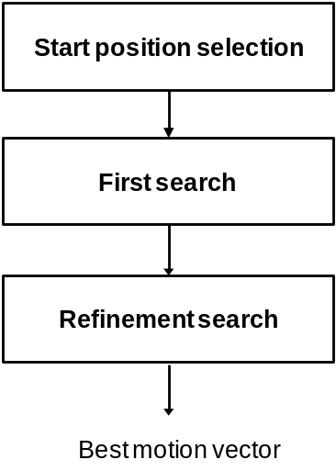
Figure 7-4 – Three step motion search strategy for integer-pel accuracy
At first, start position of the search is selected. As a default, motion vector predictor (PMV) obtained by motion vector predictor derivation process is used. Optionally, motion vectors of neighbouring positions (A, B, and C), and zero motion can be checked. In the common test condition, only PMV is used as the start position of integer-pel search.
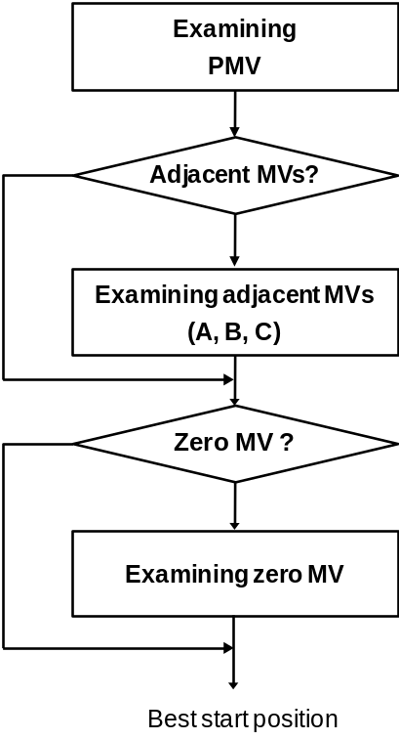
Figure 7-5 – Start position selection
As a second step, the first search is done using diamond search pattern or square search pattern. Currently, diamond search pattern is default, and square search pattern is used by changing input configuration. Additional raster search is performed when the difference between obtained motion vector and start position is too big. Currently, search range is set by 64 in integer-pel accuracy. Figure 7-6 illustrates the 3 search patterns used for the first search. Red circles represent current position and coloured squares represent candidate search positions for each pattern. Same colour means positions having same distance from the start position.
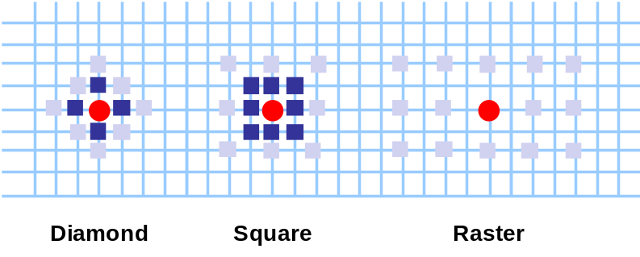
Figure 7-6 – Search patterns for the first search
Last step is refinement search. In this step, refinement search is performed by changing the start position to the best position from the second step. Also, diamond or square search is utilized, and refinement is stopped when 2 rounds are passed after best match.

Bi-predictive search strategy
In principle, bi-predictive motion search means to search two motion vectors which produce minimum error between original block (O) and predicted block with two prediction (P=P0+P1). In HM, practical strategy is implemented by utilizing iterative uni-predictive search. Bi-predictive search steps are as follows.
- Search P1 which produces minimum error with (2O - P0), where O represents original block and P0 means predictor produced by the first motion vector. P0 is fixed in this step. To get motion vector for P1, uni-predictive motion search is utilized after setting (2O - P0) as reference samples.
- Search P0 which produces minimum error with (2O – P1), where O represents original block and P1 means predictor produced by the second motion vector. P1 is the predictor obtained in step 1) and fixed in this step. To get P0, uni-predictive search is utilized after setting (2O – P1) as reference samples.
- Iterate 1) and 2) until maximum number of iterations is reached. The maximum number of iteration is set by 4 unless the fast search option is enabled.

Fast search options
There are two options to accelerate motion estimation. The first one is using sub-sampled SAD for integer motion search. This option is only used for blocks which have larger number of rows than 8. In this method, only samples in odd-number rows are involved for SAD calculations. SAD sub-sampling is only enabled when the encoder option RestrictMESampling is set to false.. The second option is reducing number of iterations for bi-predictive motion search. The number of iteration is set by 4 unless the fast search option is enabled.

Decision process on AMP mode evaluation procedure
For encoder speed up, additional conditions are checked before doing motion estimation for AMP. If certain conditions are met, additional motion estimation for AMP can be skipped. Conditions of mode skipping are based on two values: the best partition mode (PartMode) before AMP modes are evaluated and the PartMode and prediction mode (PredMode) at the lower level in the CU quad-tree, the so called parent CU, which contains the current PU. The conditions and actions are specified in Table 7-2.
Table 67-2 – Conditions and actions for fast AMP mode evaluation
Conditions | Actions
The best PartMode is SIZE_2NxN | Try SIZE_2NxnU and SIZE_2NxnD
The best PartMode is SIZE_Nx2N | Try SIZE_nLx2N and SIZE_nRx2N
The best PartMode is 2Nx2N &&  !merge mode && ! skip mode | Try all AMP modes
PartMode of parent CU is AMP mode | Try merge mode only for all AMP modes
PartMode of parent CU is PART_2Nx2N && parent CU is not skipped | Try merge mode only for all AMP modes
PredMode of parent CU is intra && the best PartMode is SIZE_2NxN | Try merge mode only for SIZE_2NxnU and SIZE_2NxnD
PredMode of parent CU is intra && the best PartMode is SIZE_Nx2N | Try merge mode only for SIZE_nLx2N and SIZE_nRx2N
Size of current CU is 64x64 | No AMP modes are evaluated

Intra/Inter/PCM mode decision
For inter coded CUs, the following mode decision process is conducted in the HM encoder. Its schematic is also shown in Figure 7-7. Please refer to contributions about early termination for Early_CU condition, CBF_Fast condition, and Early_SKIP condition.
- Coding costs (J_{mode}) for MODE_INTER with PART_2Nx2N is computed and J_{mode} is set to minimum CU coding cost J.
- Check if motion vector difference of MODE_INTER with PART_2Nx2N is equal to (0, 0) and MODE_INTER with PART_2Nx2N contains no non-zero transform coefficients (Early_SKIP condition). If both are true, proceed to 17 with setting the best interim coding mode as MODE_SKIP. Otherwise, proceed to 3.
- Check if MODE_INTER with PART_2Nx2N contains no non-zero transform coefficients (CBF_Fast condition). If the condition is true, proceed to 17 with setting the best interim coding mode as MODE_INTER with PART_2Nx2N. Otherwise, proceed to 4.
- J_{mode} for MODE_SKIP is evaluated and J is set equal to J_{mode} if J_{mode} < J.
- Check if the current CU depth is maximum and the current CU size is not 8×8 when inter_4×4_enabled_flag is zero. If the conditions are true, proceed to 6. Otherwise, proceed to 7.
- J_{mode} for MODE_INTER with PART_NxN is evaluated and J is set equal to J_{mode} if J_{mode} < J. After that, check if MODE_INTER with PART_NxN contains no non-zero transform coefficients (CBF_Fast condition). If the condition is true, proceed to 17 with setting the best interim coding mode as MODE_INTER with PART_NxN. Otherwise, proceed to 7.
- J_{mode} for MODE_INTER with PART_Nx2N is evaluated and J is set equal to J_{mode} if J_{mode} < J. After that, check if MODE_INTER with PART_Nx2N contains no non-zero transform coefficients (CBF_Fast condition). If the condition is true, proceed to 17 with setting the best interim coding mode as MODE_INTER with PART_Nx2N. Otherwise, proceed to 8.
- J_{mode} for MODE_INTER with PART_2NxN is evaluated and J is set equal to J_{mode} if J_{mode} < J. After that, check if MODE_INTER with PART_2NxN contains no non-zero transform coefficients (CBF_Fast condition). If the condition is true, proceed to 17 with setting the best interim coding mode as MODE_INTER with PART_2NxN. Otherwise, proceed to 9.
- Invoke a process to determine AMP mode evaluation procedure specified in 6.8.2.3. Output of this process is assigned to TestAMP_Hor and TestAMP_Ver. TestAMP_Hor specifies whether horizontal AMP modes are tested with specific ME or tested with merge mode or not tested. TestAMP_Ver specifies whether vertical AMP modes are tested with specific ME or tested with merge mode or not tested.
- If TestAMP_Hor indicates that horizontal AMP modes are tested, MODE_INTER with PART_2NxnU is evaluated with procedure suggested by TestAMP_Hor and J is set equal to the resulting coding cost J_{mode} if J_{mode} < J. After that, check if MODE_INTER with PART_2NxnU contains no non-zero transform coefficients (CBF_Fast condition). If the condition is true, proceed to 17 with setting the best interim coding mode as MODE_INTER with PART_2NxnU. Otherwise, MODE_INTER with PART_2NxnD is evaluated with procedure suggested by TestAMP_Hor and J is set equal to the resulting coding cost J_{mode} if J_{mode} < J. After that, check if MODE_INTER with PART_2NxnD contains no non-zero transform coefficients (CBF_Fast condition). If the condition is true, proceed to 17 with setting the best interim coding mode as MODE_INTER with PART_2NxnD. Otherwise, proceed to 11.
- If TestAMP_Ver indicates that vertical AMP modes are tested, MODE_INTER with PART_nLx2N is evaluated with procedure suggested by TestAMP_Ver and J is set equal to the resulting coding cost J_{mode} if J_{mode} < J. After that, check if MODE_INTER with PART_nLx2N contains no non-zero transform coefficients (CBF_Fast condition). If the condition is true, proceed to 17 with setting the best interim coding mode as MODE_INTER with PART_nLx2N. Otherwise, MODE_INTER with PART_nRx2N is evaluated with procedure suggested by TestAMP_Ver and J is set equal to the resulting coding cost J_{mode} if J_{mode} < J. After that, check if MODE_INTER with PART_nRx2N contains no non-zero transform coefficients (CBF_Fast condition). If the condition is true, proceed to 17 with setting the best interim coding mode as MODE_INTER with PART_nRx2N. Otherwise, proceed to 12.
- MODE_INTRA with PART_2Nx2N is evaluated by invoking the process specified in 6.8.1, only when at least one or more non-zero transform coefficients can be found by using the best interim coding mode. J is set equal to the resulting coding cost J_{mode} if J_{mode} < J.
- Check if the current CU depth is maximum, If the condition is true, proceed to 14. Otherwise, proceed to 15.
- MODE_INTRA with PART_NxN is evaluated by invoking the process specified in 6.8.1, only when the current CU size is larger than minimum TU size. The resulting coding cost J_{mode} is set to J if J_{mode} < J.
- Check if the current CU size is greater than or equal to the minimum PCM mode size specified by the log2_min_pcm_coding_block_size_minus3 value of SPS parameter. If the condition is true, proceed to 16. Otherwise, proceed to 17.
- Check if any of the following conditions are true. If the condition is true, PCM mode is evaluated and J is set equal to the resulting coding cost J_{mode} if J_{mode} < J.
- Bit cost of J is greater than that of the PCM sample data of the input image block.
- J is greater than bit cost of the PCM sample data of the input image block multiplied by λ_{mode}.
- Update bit cost B_{mode} by adding bits for CU split flag and re-compute minimum coding cost J.
- Check if the best interim coding mode is MODE_SKIP (Early_CU condition). If the condition is true, do not proceed to the recursive mode decision at next CU level. Otherwise, go to next CU level of recursive mode decision if the current CU depth is not maximum.
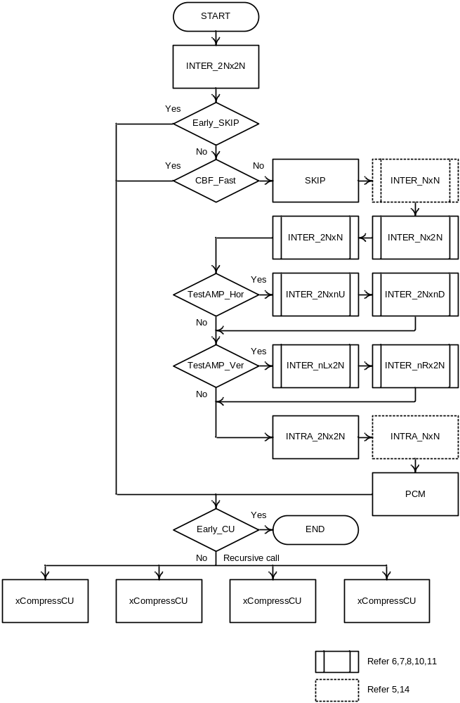
Figure 7-7 – The schematic of Intra/Inter/PCM mode decision
For the computation of J_{mode} except for PCM mode, residual signal is obtained by subtracting intra or inter prediction samples from source samples and is coded with transform and quantization with quad-tree TU partitioning as specified in the section 6.9. Bits for side information (skip_flag, merge_flag, merge_idx, pred_type, pcm_flag, inter_pred_flag, reference picture indices, motion vector(s), mvp_idx, intra prediction mode signaling) and residual coded data are considered as B_{mode}. SSE_{luma} and SSE_{chroma} are obtained by using local decoded samples, except for MODE_SKIP case where prediction sample is used as local decoded samples.
For the computation of J_{mode} for PCM mode, bits for side information (skip_flag, pred_type, pcm_flag, pcm_alignment_zero_bit) and PCM sample data are considered as B_{mode}. SSE_{luma} and SSE_{chroma} are set to 0. (Note that in current test conditions, the PCM mode decision processes in (15) and (16) are skipped since the minimum PCM mode size is 128.)
This CU level mode decision is recursively performed for each CU depth and final distribution of CU coding modes is determined at CTU level.

Adaptive QP
This tool varies the quantization parameter for each coding unit to provide improved perceived image quality. QP variation is performed using the same technique originally implemented in the MPEG-2 TM5 which works according to the following rationale: lower QP values are used on smooth image areas while higher values on highly active blocks. The activity of each CU is measured by the variance of its luma samples. More precisely, given a CU with size 2N×2N, the luma variance of its four sub blocks with size N × N is computed first. Let σ²(i) denote the luma sample variance for sub block i. The CU activity (act_{CU}) is then computed as:
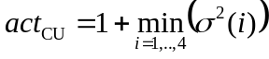,
In order to increase QP values on highly active image areas and decrease in smooth ones, the quantity act_{CU} is then normalized with respect to the average activity measured over all coding units with size 2N × 2N inside one picture. Let act_{f} denote the average activity for all CUs with size 2N × 2N belonging to picture f. The normalized CU activity norm_act_{CU} is then given by:
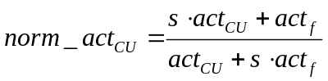,
where s denotes the scaling factor associated to the QP adaptation parameter (QPA) and computed as:
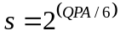.
The value for QPA is provided as input using the configuration option MaxQPAdaptationRange and has default value of 6. Finally, the coding unit QP is adjusted according to:
,
where QP_{base} denotes the QP value for the slice where the coding unit belongs to and ⎣⋅⎦ operator returns the largest integer smaller than or equal to the argument. The adaptive QP tool is enabled by the configuration option AdaptiveQP. The minimum CU size at which QP can be adapted according to its normalized activity is specified by the configuration option MaxCuDQPDepth whose value should always be less than the maximum CU depth.

Derivation process for TU-level coding parameters

Residual Quad-tree partitioning
The residual quadtree is a recursive representation of the partitioning of a coding unit into transform units.
The encoding process for intra-coded coding units can be summarized as follows.
– The luma intra prediction mode (or modes for intra_split_flag equal to 1) is determined using the residual coding with the largest applicable transform size.
– Given the determined luma intra prediction mode (or modes for intra_split_flag equal to 1), the transform tree and the corresponding luma transform coefficient levels are determined using an exhaustive subdivision process, taking into account the maximum allowed transform hierarchy depth and considering only the luma component.
– The chroma intra prediction mode and the corresponding chroma transform coefficient levels are determined given the determined transform tree.
The encoding process for inter-coded coding units can be summarized as follows.
– The transform tree and the corresponding luma and chroma transform coefficient levels are determined using an exhaustive subdivision process, taking into account the maximum allowed transform hierarchy depth and considering both the luma component and the chroma components.

Rate-distortion optimized quantization
Rate-distortion optimized quantization (RDOQ) is enabled by the encoder option --RDOQ and performs soft decision quantization for each transform coefficient by minimizing a rate-distortion Lagrangian cost function. More specifically, over a transform unit with size B each coefficient c_{i} (for i = 0,…,B² – 1) is quantized to the following three level values: 0, l_{floor} and l_{ceil}. The value for l_{floor} is the one computed for the selected QP and according to [1]. Conversely, l_{ceil} = l_{floor} + 1. For each level value l, the following Lagrangian cost function J is computed:
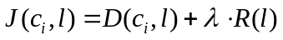
where λ denotes the Lagrangian multiplier computed as described in Section 6.5.4.1, D(c_{i}, l) is the distortion measured when c_{i} is quantized to l and R(l) is the (estimated) coding rate associated to l. The value for l (i.e. 0, l_{floor} or l_{ceil}) which minimizes J is selected as the best one and the process moves to the next coefficient. The coefficients c_{i} are processed according to the scanning order used for the transform unit where they belong to and starting from the last significant coefficient (i.e. from the one associated to i = B² – 1). This particular processing order is used to mimic actual entropy encoding. In order to keep low computational complexity during RDOQ, the coding rate R(l) is estimated by tabularized values of entropy of the probabilities corresponding to states in CABAC coding engine. RDOQ can be used also for those transform units where the transform skip is selected. In this case the processing is identical and this option can enabled or disabled by the encoder option --RDOQTS.

Quantization rounding for residual DPCM
Over blocks where both transform skip and residual DPCM (RDPCM, see Section 4.7) are applied, the quantization rounding offset is different from the one used in spatially transformed blocks. More precisely, the HM-RExt 7 software applies a dead zone uniform quantizer with quantization step Q and rounding offset α as shown in Figure 7-8. For blocks where spatial transformation is applied, α is equal to 1/3 and 1/6 for intra and inter coding modes, respectively. Conversely, over blocks where transform skip and RDPCM are used, the offset α is set equal to1/2.
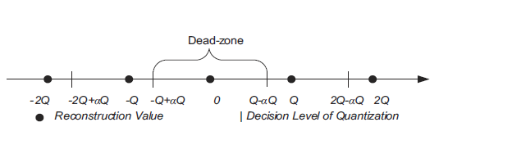
Figure 7-8 – Dead zone uniform quantizer with rounding offset.

Cross-component prediction
Cross component prediction (CCP) predicts each chroma transform block by its co-located reconstructed luma transform block. CCP is available for 4:4:4 chroma format only and assumes a linear model for the correlation between the luma and chroma components. More precisely, let r_{C}(x,y) be the residuals associated with the chroma component for pixel located at (x,y). Let also r’_{L}(x,y) be the reconstructed residuals for the luma component at the same spatial location. . The CCP chroma residual, Δr_{C}(x,y), for the same spatial location is obtained as:

where α denotes the linear model parameter which is selected on a chroma transform block basis. By using the luma residuals, the implementation complexity is reduced and pipelining and parallel processing are facilitated as the prediction can be performed without waiting until reconstruction of luma residual signal. Ten different values for α are specified in the standard and the encoder selects the best value based on the following:
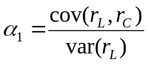
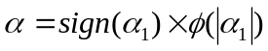
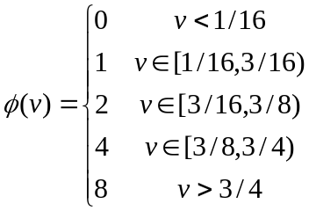
where cov(·) and var(·) denote the covariance and variance operation, respectively.

Transform skip selection
The transform skip is allowed for large TUs by a RDO with the transform mode. The maximum size allowed is specified by TransformSkipLog2MaxSize. There is one fast mode decision specified by setting TransformSkipFast to 1, which skips the transform skip on luminance intra coding when the PartMode is not PART_NxN and on chrominance intra coding when all corresponding luminance TUs are not coded in transform skip mode. Therefore, to enable the transform skip on large TUs when the PartMode is PART_2Nx2N for intra coding, the TransformSkipFast option should be set to 0. Another fast method for transform skip is to disable the RDOQ when a TU chooses the transform skip mode, which is achieved by setting RDOQTS to 0.

References
- C. Rosewarne, B. Bross, M. Naccari, K. Sharman, G. Sullivan, “High Efficiency Video Coding (HEVC) Test Model 16 (HM 16) Encoder Description Update 2”, JCTVC-T1002, June 2015.
- F. Bossen, D. Flynn, K. Sharman, K. Suhring, “HM Software Manual”, September 2014.
- D. Flynn, M. Naccari, K. Sharman, C. Rosewarne, J. Sole, G. J. Sullivan, T. Suzuki, “High Efficiency Video Coding (HEVC) Range Extensions text specification: Draft 7”, JCTVC-R1013, July 2014.
- F. Bossen, “Common HM test conditions and software reference configurations”, JCTVC-L1100, February 2013.
- C. Rosewarne, K. Sharman, D. Flynn, “Common test conditions and software reference configurations for HEVC range extensions”, JCTVC-P1006, January 2014.
- B. Li, H. Li, L. Li and J. Zhang, “Rate control by R-lambda model for HEVC”, JCTVC-K0103, October 2012.
- R. Sjoberg, Y. Chen;A. Fujibayashi; M. M. Hannuksela, J. Samuelsson, T. K. Tan; Y.-K. Wang and S. Wenger, “Overview of HEVC High-Level Syntax and Reference Picture Management”, IEEE Transactions on Circuits and Systems for Video Technology, vol. 22, no. 12, pp. 1858-1870, December 2012.
- Y.-J. Ahn, X. Wu, W. Lim, D. Sim, “Target bits saturation to avoid CPB overflow and underflow under the constraint of HRD”, JCTVC-U0132, June 2015.

